SOMERSET

EXAMINATION COVER SHEET

ENGLISH (HOME LANGUAGE) GRADE 5

PAPER (LANGUAGE) DURATION: 90 minutes

DATE: THURSDAY 1 DECEMBER 2016 TOTAL MARKS: 65 marks

EXAMINER: MS J MARTIN MODERATOR: MR G BUDD

INSTRUCTIONS:

• This examination consists of TWO sections:
READING SKILLS (Questions 1-4) and GRAMMAR SKILLS (Questions 5-8)
• You may answer the questions in any order.

SOME

READING SKILLS 40 marks (Write your answers on the lin
QUESTION ONE 14 marks

QUESTION ONE

Read the following extract from ‘The Snow Goose’ written by Paul Gallico.

In the late spring of 1930 Philip Rhayader bought an old lighthouse near a village that was close to the sea. He lived and worked alone there, painting pictures of birds and of nature. The villagers looked suspiciously at his mis-shapen body, for he was a hunchback and his left arm was crippled, thin and bent at the wrist, like the claw of a bird.

One November afternoon, a child approached the lighthouse where he lived. In her arms she carried a burden. Although she was desperately frightened of the ugly man she had come to see, she knew that this ogre who lived in the lighthouse could heal injured things.

She had never seen Rhayader before and was close to fleeing in panic when he appeared at the door of the lighthouse. She stood there, staring at the black head and beard, the sinister hump, and the crooked claw, but his voice was deep and kind when he spoke to her, ‘What is it, child?
She stood her ground, and then edged timidly forward. The thing she carried in her arms was a large white bird and it was quite still. There were stains of blood on its whiteness and on her dress where she had held it to her. The girl placed it in his arms. ‘I found it, sir. It’s hurted. Is it still alive?’
‘Yes. Yes, I think so. Come in, child, come in.’
Rhayader went inside, carrying the bird, which he placed upon a table, where it moved feebly. Curiosity overcame fear. The girl followed and found herself in a room warmed by a coal fire. The bird fluttered. With his good hand, Rhayader spread one of its immense white wings. The end was beautifully tipped with black.
Rhayader looked and marvelled, and said, ‘Child, where did you find it?’
‘In t’ marsh, sir, where bird hunters had been. What -what is it, sir?’
‘It’s a snow goose from Canada. Ah, she has been shot, poor thing. Her leg is broken, and the wing tip, but not badly. See, we will clip her feathers, so that we can bandage it close to her body, so that she cannot move it until it has set, and then make a splint for the poor leg.’

He reached into his pocket and produced a handful of grain. The snow goose opened its round yellow eyes and nibbled at it. The child laughed with delight, and then suddenly caught her breath with alarm when she remembered where she, and without a word she turned and fled out of the door.
‘Wait, wait!’ cried Rhayader, and went to the entrance, where he stopped so that it framed his dark bulk. The girl was already fleeing down the sea wall, but she paused at his voice and looked back.
‘What is your name, child?’
‘Frith.’
‘Where do you live?’ asked Rhayader.
‘Wi’ t’ fisherfolk at Wickaeldroth.’ She gave the name the old Saxon pronunciation.
‘Will you come back tomorrow, or the next day, to see how the bird is getting along?’
Her thin voice came back to him, ‘Ay!’
And then she was gone, with her fair hair streaming out behind her.

Answer the questions carefully. Circle the letter of the correct answer.

- Who is the main character in this story? (1)
- The snow goose
- Rhayader
- Frith

- What is the setting of this story? (1)
- A village
- The sea
- A lighthouse near a village

- Why were the villagers suspicious of the man who lived in the lighthouse? (1)
- He spoke a strange language
- He has physically disabled
- He was an ogre

- Why did the girl approach Rhayader for help? (1)
- She had found a heavy duck.
- She had found a wounded duck.
- She had found a wounded bird.

- The girl spoke a strange type of English. This is called (1)
- Standard English
- Swearing
- A dialect

- Do you think Frith would have told the villagers that she had gone to ask Rhayader
For help? Explain your opinion. (2)
_________________________________________________________________________________________________________________________________________________________________________________________________________
- What do you think could happen next in the story? (3)
_____________________________________________________________________________________________________________________________________________________________________________________________________________________________________________________________________________________________________________________________________________________________________________________________________________________________________________________________________________________
[10 marks]

QUESTION TWO

Read the following poem.
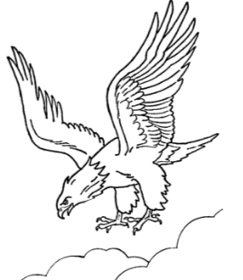
The Eagle by Alfred Tennyson

He clasps the crag with crooked hands;
Close to the sun in lonely lands,
Ring’d with the azure world, he stands.

The wrinkled sea beneath him crawls;
He watches from his mountain walls,
And like a thunderbolt, he falls.

- How many stanzas are in this poem? (1)
__________
- What is the rhyming scheme of this poem? (1)
__________
- The poet is describing the eagle in this poem.
- Name the figurative device used to describe the eagle’s claws. (1)
_____________________________
- What are the eagle’s claws being compared to? (1)
________________________________________________________________________________________________________________________________
- The eagle is on the top of a mountain.
- What clue does the poet give to show that a crag is a mountain? (1)
________________________________________________________________________________________________________________________________
- What is the ‘azure world’? (1)
____________________________
- Why is the sea wrinkled? (1)
________________________________________________________________________________________________________________________________
- Quote the simile in the poem. (1)
________________________________________________________________
[8 marks]
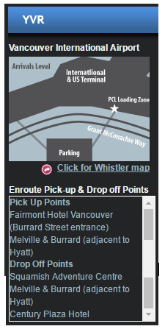
QUESTION THREE

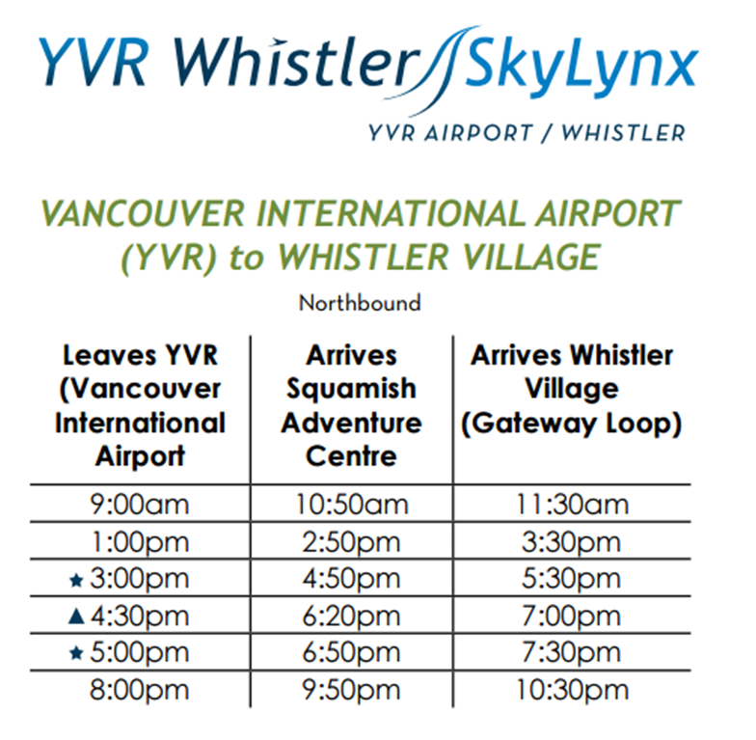
Study the bus timetable from Vancouver International Airport.

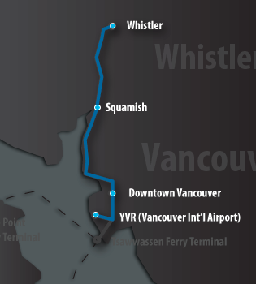

- What does YVR stand for? (1)
_____________________________________________________________________
- What do you think is meant by ‘Gateway Loop’? (1)
____________________________________________________________________________________________________________________________________________
- How long does it take for the bus to travel from Squamish to Whistler village? (1)
_____________________________
- How many times does a bus leave for the Squamish Adventure Centre? (1)
_____________________________
- Does the bus go directly to the Squamish Adventure Centre? Explain. (1)
____________________________________________________________________________________________________________________________________________
- The bus trips are fairly spaced out, except for the bus that leaves the airport at 4:40 pm and 5:00pm. What could be the reason for this? (1)
____________________________________________________________________________________________________________________________________________
- If someone misses the last bus to Whistler Village, how long must they wait before the next one? (1)
___________________________________ [7 marks]
QUESTION FOUR

Explain the humour of the following jokes.

________________________________________________________________________________________________________________________________________________________________________________________________________________________________________________________________________________________________

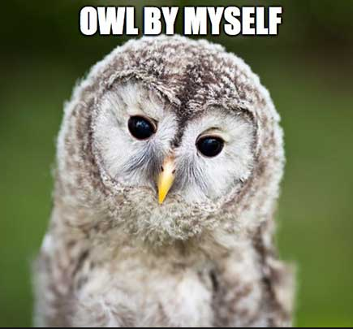
- ____________________________________________________________________________________________________________________________________________________________________________________________________________________________________________________________________________________________________________________________________

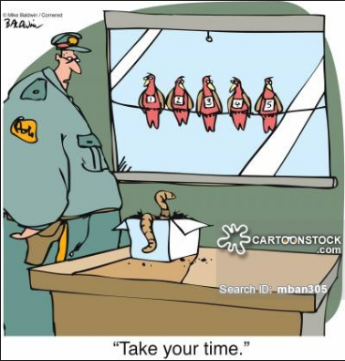
____________________________________________________________________________________________________________________________________________________________________________________________________________________________________________________________________________________________________________________________________________________________

- Which cartoon do you think matches the story about the Snow Goose best? Explain your answer carefully. (2)

________________________________________________________________________________________________________________________________________________________________________________________________________________________________________________________________________________________
[5 marks]

QUESTION FIVE

Read the text below. Name the parts of speech of the bolded words. Write your answers in the table below the text.

A kind, German woman who had no children, longed for a baby and would often say, “How I would love to have a baby girl, even a tiny little one.”
A beautiful fairy heard her wish one day, and gave her a little seed to plant in a flowerpot.
When the seed bloomed into a tulip, the woman saw a tiny, beautiful girl inside, no bigger than her thumb. She decided to call her Thumbelina. She was so small that she had a walnut shell for a bed and used petals as a blanket.
Then, an ugly toad fell in love with Thumbelina. One night when she was sleeping, he carried her off to his lily pad in a pond. Thumbelina was very unhappy. A swallow who was passing by saw how sad she looked, and said, “Come south with me to warmer lands.”
Young Thumbelina flew away on the swallow’s back. They flew across the seas and came to a land of sunshine. The swallow said, ”This is my home. You can live in one of the loveliest and biggest flowers.” When Thumbelina stepped inside, she found a handsome fairy, as tiny as her, in its heart.
He was the son of the king of flowers and he fell in love with Thumbelina. He asked her to marry him. So Thumbelina became queen of the flowers and the two lived happily ever after.

Word from the text | Part of speech | Word from the text | Part of speech
German |  | to
longed |  | very
love |  | warmer
wish |  | its
Thumbelina |  | and

[10 marks]

QUESTION SIX

Read the following sentences. Then answer the questions by writing ‘yes’ or ‘no’. If your answer is ‘YES’, write the correction. Only write the word, not the sentence.
- My friend and I are planning to build a model aeroplane.
Does this sentence contain an error? YES NO ________________________________
- The instructions printed on the box showed my friend and I what to do.
Does this sentence contain an error? YES NO_________________________________
- We spent hours building the model and had tons of fun!
Does this sentence contain an error? YES NO_________________________________
- Its important that everyone has a hobby.
Does this sentence contain an error? YES NO_________________________________
- Sadly, my friend said that the completed model was her’s.
Does this sentence contain an error? YES NO_________________________________
- We couldnt agree on whose model it was.
Does this sentence contain an error? YES NO_________________________________
- Oh dear! My dog, who was feeling bored, decided to chew up the model aeroplane!
Does this sentence contain an error? YES NO_________________________________
[7 marks]

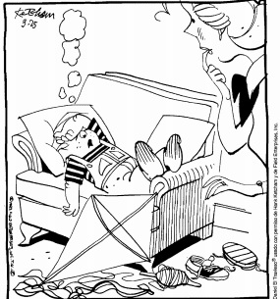
QUESTION SEVEN

Use the cartoon about Dennis the Menace
for inspiration to write Direct Speech sentences.

- Begin with the introductory verb
_________________________________________________________________________________________________________________________________________________________________________________________________________
- End with the introductory verb
_________________________________________________________________________________________________________________________________________________________________________________________________________
- Interrupt the sentence with the introductory verb
_________________________________________________________________________________________________________________________________________________________________________________________________________

[8 marks]

QUESTION EIGHT
Use the picture for ideas to write different kinds of sentences.
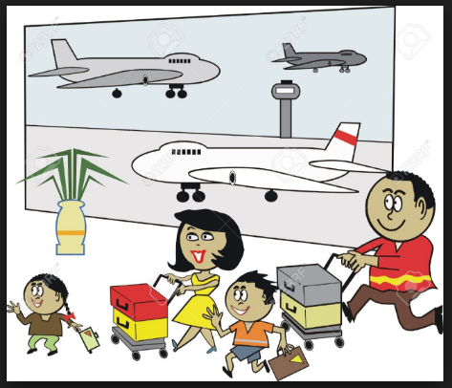

- Simple sentence ______________________________________________________________________________________________________________________________________
- Compound sentence
______________________________________________________________________________________________________________________________________
- A simple sentence ending with an adverbial phrase of place.
______________________________________________________________________________________________________________________________________
- Use a relative pronoun in a sentence. Underline the relative pronoun.
______________________________________________________________________________________________________________________________________
- Write a sentence that has a possessive pronoun. Underline the possessive pronoun.
______________________________________________________________________________________________________________________________________
[10 marks]

