SOMERSET

EXAMINATION COVER SHEET

ENGLISH (HOME LANGUAGE) GRADE 6

PAPER (LANGUAGE) DURATION: 1 HOUR

DATE: MONDAY 6 JUNE 2016 TOTAL MARKS: 60

EXAMINER: MS J MARTIN MODERATOR: MR G BUDD

INSTRUCTIONS:
- This paper consisits of EIGHT questions.
- Write all your answers on the question paper.
- Questions 1 and 2 are comprehension questions
- Read the questions carefully.
- Answer the questions in full, contextual sentences. (PE)
- Check the mark allocation carefully.
- CHECK YOUR WORK

SOMERSET

QUESTION 1 15 marks
Read the following text carefully:
Tarantula: another name for terror by: Terri Coffman
Catchy title, huh? However, it’s not exactly accurate. To be more precise, at least as far as I'm concerned, terror is ANY spider. Size is not relative. The clinical term for my fear is arachnophobia — the fear of spiders — and mine was born one rainy night in the middle of a Central American Rainforest when I was eleven years old. It has had a huge effect on my life ever since.
Living in the jungle in Belize, in a thatched roof house with open doors and windows, one became accustomed to all kinds of unwelcome visitors. But the most unwelcome of all was a big, black, hairy tarantula that stretched close to 25cm from leg to leg and stood almost 12cm high. Unfortunately for him as well as for me, he fell from the wall into my bed, covering the entire indentation on the pillow where my face would have been. In the split seconds that followed my ear-splitting screams, the monstrous thing was killed by my broom-wielding dad. And, as Fate would have it, the spider ended up in my bed a second time, this time squashed and mangled, and definitely dead.
I remember just standing there, numb, watching my dad toss the mangled mess out the window. Then, somewhere from a hazy distance, I heard my mom say the bedding was changed and it was alright to go back to bed, but I was paralyzed. I couldn't move. I was literally frozen with fear! Only one thought kept flashing through my mind: what if that spider had fallen on my face while I was sleeping? What if.....? What if.....? What if.....?
Logically, I knew the poor thing was just as frightened as I was. It hadn’t been lying in wait to attack me; it was simply trying get out of the rain, and if I had not knocked it off the wall getting into bed, the tarantula would have, in all probability, gone up into the the roof to find food, and we would have never known it was up there. To this day, rationally, I know spiders, in general, are beneficial to man, but the mere mention of the word sends chills through me.
Answer the following questions carefully, in full sentences. Remember to keep your answers in context at all times.
- Why is the title catchy? (1)
- Why does the writer say the title of the text is not entirely accurate? (1)
- What is ‘arachnophobia’? (1)
- What is the difference between a rational fear and one that is irrational? (2)
- Why should the writer have expected to see spiders in her room? (2)
- Why did the spider land on her bed the first time? (1)
- Why do you think the spider landed on her bed a second time? (1)
- List two other kinds of ‘unwelcome visitors’ one should expect to see in the same environment. (2)
- Pretend you are the girl who has just been frightened by the spider. You keep a diary. Write ONE sentence in your diary about the experience. (2)
- Pretend you are the girl’s unsympathetic younger brother. You also keep a diary. Write ONE sentence about her experience. (2)

QUESTION 2 10 marks
The spider by Shel Silverstein
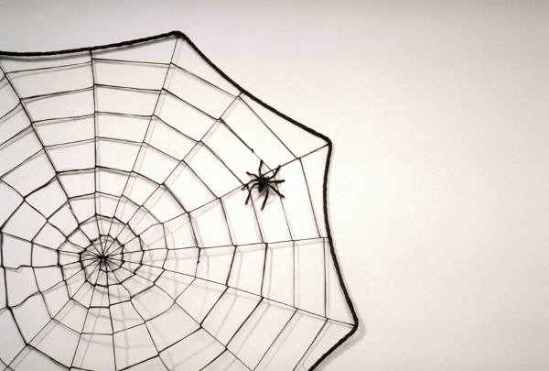
A spider lives inside my head
Who weaves a strange and wondrous web
Of silken threads and silver strings
To catch all sorts of flying things,
Like crumbs of thought and bits of smiles
And specks of dried-up tears,
And dust of dreams that catch and cling
For years and years and years . . .

- What does the spider create in the poem? (1)
- Quote ONE example of alliteration in this poem. (1)
- Is line 5 in the poem an example of a simile? Explain your answer. (2)
- List TWO verbs from the poem. (2)
- List ONE possessive adjective from the poem. (1)
- Summarise the poem in ONE clear sentence. (1)
- Write a simple sentence about a spider. (1)
- Write a compound sentence about a spider. (1)

Part of speech | Answer
Proper noun(Type of spider)
Common noun

Descriptive adjective

Adverb of manner

Action verb

QUESTION 3 5 marks
Use the sketch below to help you describe the spider in the ‘spider table’. Write a short sentence. Underline the word in the sentence.
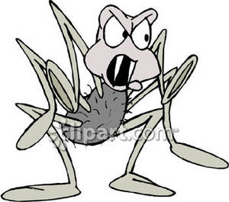

QUESTION 4 9 marks
Name the underlined words in the following sentences:
- The spider was spinning a web. _______________________________________
- The spider is poisonous. _______________________________________
- The spider looks fierce. _______________________________________
- That spider is beautiful! _______________________________________
- Not all spiders eat their mates. _______________________________________
- The spider is hunting for its prey. _______________________________________
- The spider preys on insects. _______________________________________
- The spider was in the garden. _______________________________________
- The spider spins beautifully. _________ _____________________________

QUESTION 5 6 marks
I don’t know why people are so scared of me!

Rewrite Sally Spider’s sentence in direct speech. Show that you know how to use the introductory verb in three different ways.
_____________________________________________________________________________________________________________________________________________________________________________________________________________________________________________________________________________________________________________________________________________________________________________________________________________________________________________________________________________________________________________________________________________________________________________________________________________________________________________________

QUESTION 6 3 marks

Write your own sentences about spiders and include the punctuation mark shown in brackets.

- (Question Mark)
__________________________________________________________________________________________________________________________________________________________________________________________________________
- (Exclamation mark)
__________________________________________________________________________________________________________________________________________________________________________________________________________
- (Brackets)
__________________________________________________________________________________________________________________________________________________________________________________________________________

QUESTION 7 9 marks (Negative marking)
There are all sorts of mistakes in the paragraph. Edit the paragraph and rewrite it correctly.
There is a greek mith about a country girl named arachne he was a wonderful spinner of threads as the myth goes, the greek goddess athena was very jealous of Arachne, arachne bragged that she was a many more talented weaver than athena and challenged the goddess to a weaving contest arachne was quite arrogant and again insulted the goddess by weaving pictures that made the gods look bad athena become so angry that she turned arachne into a spider and forced her to live the rest of her live weaving webs
________________________________________________________________________________________________________________________________________________________________________________________________________________________________________________________________________________________________________________________________________________________________________________________________________________________________________________________________________________________________________________________________________________________________________________________________________________________________________________________________________________________________________________________________________________________________________________________________________________________________________________________________________

QUESTION 8 3 marks

Read the paragraphs below carefully. Decide whether they have been correctly structured. Place a tick in the appropriate box below the paragraphs to reflect your assessment of the texts.
Paragraph 1
Stanley Yelnats and his family have a history of bad luck. The first Stanley's great grandfather made a fortune on the stock market. The family's bad luck struck him when he moved from New York to California and was robbed by Kissin' Kate Barlow. Stanley's father is an inventor. He works very hard and is smart, however, none of his inventions ever work. Stanley is accused of a crime he didn't commit and is sent to Camp Green Lake as punishment. It seems none of the Yelnats can escape the family curse.
Paragraph 2
Camp Green Lake dried up and the people who lived near it moved away over a hundred years ago. Now the lake is desert-like with temperatures around ninety-five degrees. Deserts cover one-fifth of the Earth's surface. The only place to find shade is between two trees in the Warden's yard. Rattlesnakes and scorpions hide under rocks and in the holes the campers dig. Deserts do not have many large animals because there is not enough water for them to survive.
Paragraph 3
Stanley's father was an inventor. He was trying to discover a way to recycle old sneakers. Clatonia Joaquin Dorticus invented an apparatus for applying dyes to the sides of the soles and heels of shoes. George de Mestral invented Velcro. While hiking, he had noticed that burrs stuck to his clothing. He used this idea to develop one strip of nylon with loops, and another with hooks.

 | Correctly structured | Incorrectly structured
Paragraph 1
Paragraph 2
Paragraph 3

