TEXT 1
35
30
25
20
15
10
5
Vincent van Gogh 1853 – 1890

Vincent Willem van Gogh was a Dutch Post-Impressionist painter who is among the most famous and influential figures in the history of Western art.

The son of a minister, van Gogh started working at age 16, when his uncle got him a job as a trainee with an art dealership in The Hague. He went on to do stints in the firm’s London and Paris offices before he was fired in 1876. Afterwards, he worked briefly as a schoolteacher in England then at a bookstore back in the Netherlands. In 1878, he went to the Borinage, a mining district in Belgium, and worked among the poor as a lay preacher. He gave away his belongings and slept on floors, but after less than a year on the job, the religious organisation sponsoring van Gogh decided he wasn’t cut out to be a pastor and dismissed him. His next career choice, artist, would of course make him internationally famous, although not until after his death.

Van Gogh went to Paris where he devoted himself to drawing and painting, but sadly his work was largely ignored. His younger brother, Theo, an art dealer, helped support him financially and emotionally. Two years later he moved to Arles in the south of France with his friend, Paul Gauguin - an artist (whose work, like Vincent’s, had yet to receive widespread acclaim).On the night of December 23, 1888, the two men argued and Gauguin left their house. Van Gogh, armed with a razor, followed his fellow artist out onto the street; however, rather than attacking him, the Dutchman returned home, cut off part of his left ear, wrapped it in newspaper then gave it to a passer-by. This is the commonly held version of what happened; however, in 2009 two German academics published a book in which they made the case that Gauguin, a talented fencer, sliced off a portion of van Gogh’s ear with a sabre during a dispute. According to this theory, van Gogh, who didn’t want to lose the friendship, agreed to cover up the truth about the incident in order to prevent Gauguin from going to jail.

In May 1889, van Gogh, who’d experienced episodes of poor mental health in the previous months, checked himself into Saint Paul de Mausole, a mental hospital located in a former monastery in the town of Saint-Remy-de-Provence in southern France. He stayed at the hospital for a year, during which time he painted scenes of its gardens as well as the surrounding countryside. The more than 100 paintings he produced during this period include some of his most celebrated works, such as “The Starry Night”.

The long-held theory about van Gogh’s death is that on July 27, 1890, he shot himself in the abdomen while painting in a wheat field in Auvers-sur-Oise, France, then walked about a mile back to the inn where he was staying and passed away there two days later. However, in a 2011 biography of van Gogh, its respected co-authors offered an alternative theory: He was accidentally shot by a teenage boy who was known to have mocked van Gogh, but the lonely painter said his wound was self-inflicted because he felt the teen was helping him out by pulling the trigger, thereby putting an end to van Gogh’s unhappiness and ensuring he was no longer a financial burden to Theo. The authors claimed their theory was supported by a variety of evidence, including the fact that the gun, along with the painting supplies van Gogh supposedly took with him to the wheat field, were never found. Additionally, if van Gogh had shot himself, it would’ve been tough for someone in his condition to make it all the way from the wheat field back to the inn.

TEXT 2
Starry starry night by Don McClean

Starry, starry night. 1
Paint your palette blue and grey,
Look out on a summer's day,
With eyes that know the darkness in my soul.
Shadows on the hills, 5
Sketch the trees and the daffodils,
Catch the breeze and the winter chills,
In colours on the snowy linen land.

Now I understand what you tried to say to me
How you suffered for your sanity 10
How you tried to set them free.
They would not listen
They did not know how
Perhaps they'll listen now.

Starry, starry night. 15
Flaming flowers that brightly blaze, Swirling clouds in violet haze,
Reflect in Vincent's eyes of china blue.
Colours changing hue, morning field of amber grain,
Weathered faces lined in pain,
Are soothed beneath the artist's loving hand. 20

For they could not love you,
But still your love was true.
And when no hope was left in sight
On that starry, starry night,
You took your life, as lovers often do. 25
But I could have told you, Vincent,
This world was never meant for one
As beautiful as you.

Starry, starry night.
Portraits hung in empty halls, 30
Frameless head on nameless walls,
With eyes that watch the world and can't forget.
Like the strangers that you've met,
The ragged men in the ragged clothes,
The silver thorn of bloody rose, 35
Lie crushed and broken on the virgin snow.

Now I think I know what you tried to say to me,
How you suffered for your sanity,
How you tried to set them free.
They would not listen, they're not listening still. 40
Perhaps they never will...

TEXT 3
My Life by Billy Joel

I don't need you to worry for me 'cause I'm alright 1
I don't want you to tell me it's time to come home
I don't care what you say anymore this is my life
Go ahead with your own life leave me alone

I never said you had to offer me a second chance 5
I never said I was a victim of circumstance
I still belong
Don't get me wrong
And you can speak your mind
But not on my time 10

I don't care what you say anymore this is my life
Go ahead with your own life leave me alone

TEXT 4
Autumn by Alan Bold

Autumn arrives 1
Like an experienced robber
Grabbing the green stuff
Then cunningly covering his tracks
With a deep multitude 5
Of colourful distractions.
And the wind,
The wind is his *accomplice
Putting an air of chaos
Into the careful *diversions 10
So branches shake
And dead leaves are suddenly brown
In the faces of inquisitive strangers.
The theft chills the world
Changes the temper of the earth 15
Till the normally *placid sky
Glows red with a quiet rage.

Glossary
*accomplice: a person who helps someone commit a crime
*diversions: creating an alternative route
*placid: not easily upset or excited

TEXT 5

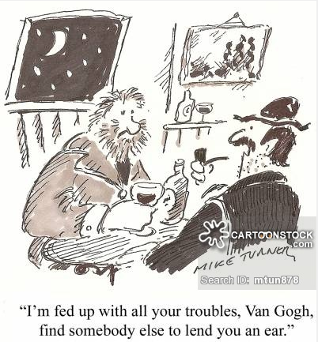
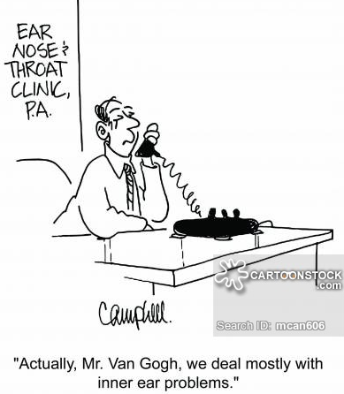

B
A

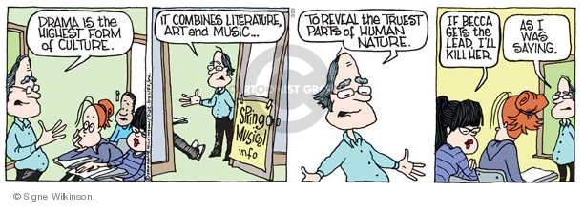
FRAME 4
FRAME 3
FRAME 2
FRAME 1
C

TEXT 6
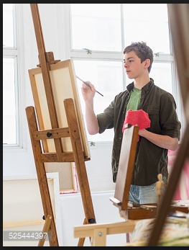
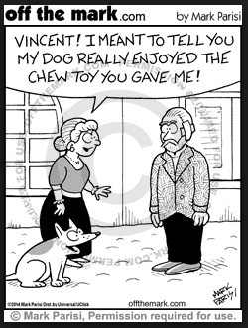

B
A

