TEXT 1

|  |
| --- |
| Extract from the novel called *A Deadly Presence* by Hjalmar Thesen.  For the second time in his life the black leopard had known fear, and when the two-legged creatures came so close, his anger had changed swiftly to an adrenalin-triggered survival instinct that obliterated even the pain of his wounded paw. In his plunge to safety he would certainly have mauled these creatures who stalked him, for they were large and he was wary of them. Now in the cool forest he moved slowly on three legs in an unnaturally ungainly manner.  From time to time he stopped to lick the steadily bleeding stump and after each period of licking he sat still, his injured back leg held up and away from the forest floor, listening for alien sounds. Very faintly they came to him, small false notes above the midday medley of the forest, and his ears moved and swivelled as though each sound carried its own tiny physical impact.  The black leopard was hungry and thirsty and weak from loss of blood but the sounds were retreating and he was not conscious of any immediate danger beyond the pain and stiffness in his shoulder when he moved and the dull ache in his lower leg. Against the dark green of the forest undergrowth, and the checkering of grey-black shadows, his camouflage was perfect, but in the shaft of sunlight that flooded over him as he moved, lighting the jet-black hide to a gloss that was silver-tipped with shine, there was also a flash of deepest red; shoulder and back the wound was long and deep and still oozing blood. It was also dangerously out of reach of his tongue and flies hovered about him, skipping in and out of the sun shaft, small specks of green, like the cold emerald green of his eyes. |

TEXT 2

|  |
| --- |
| **A TASTE FOR THE WILD**  **Capetonian Paula McAravey whets her appetite for the bush and goes**  **back to her roots on a visit to Nambiti Game Reserve and Rorke’s Drift.**  “When walking to and fro from your rooms at night, please ask a ranger to  accompany you. Because this is an unfenced camp, lion, elephant and buffalo  often walk through the camp.” These words of warning, together with the  indemnity form we were asked to sign on arrival, were the first indications that  I’d left my comfort zone behind in the city. Still, I had exchanged it for a far  more comfortable zone – five-star luxury of a lodge in Nambiti Private Game  Reserve in northern KwaZulu-Natal, with an outdoor bush shower, a suite with  floor-to-ceiling panoramic views and meals to satisfy the most discerning  appetite. Nambiti means “to taste” in Zulu and from the moment we arrived I  found myself greedily lapping up the tastes, sights and sounds of the bushveld  – South Africa at its natural best.  **HISTORY AND HERITAGE.**  But I wasn’t here just for wild encounters. I was also visiting Nambiti to explore  our country’s heritage, as well as my own. Nambiti and the surrounding areas  are steeped in history. Guided tours can also be arranged to nearby  Islandlwana, the site of one of the worst defeats ever suffered by the British,  and to Rorke’s Drift, where 150 British soldiers successfully defended the  garrison against 3 000 to 4 000 Zulus with the help of a barricade made from  boxes of biscuits and bags of mealies! We visited the sites of the battles at  Elandslaagte and Rorke’s Drift; we climbed up koppies and stood in fields  surrounded by rolling hills and grasslands, and listened as our guides brought  history to life.  **SCENIC ROUTES AND HISTORICAL ROOTS**  As well as being mesmerised by our country’s wildlife, this trip re-emphasised  for me the importance of knowing where you come from and celebrating your  own heritage. It made me want to dig further into my family history – and I now  regret not having paid more attention during history lessons at school! I’ve  always thought of myself as a beach girl rather than a bush baby, but I  discovered that the bush is truly balm for the soul – a place of rest and to  recharge tired batteries. And now that I’ve had a taste of it, I can’t wait for the  next course! |

TEXT 3

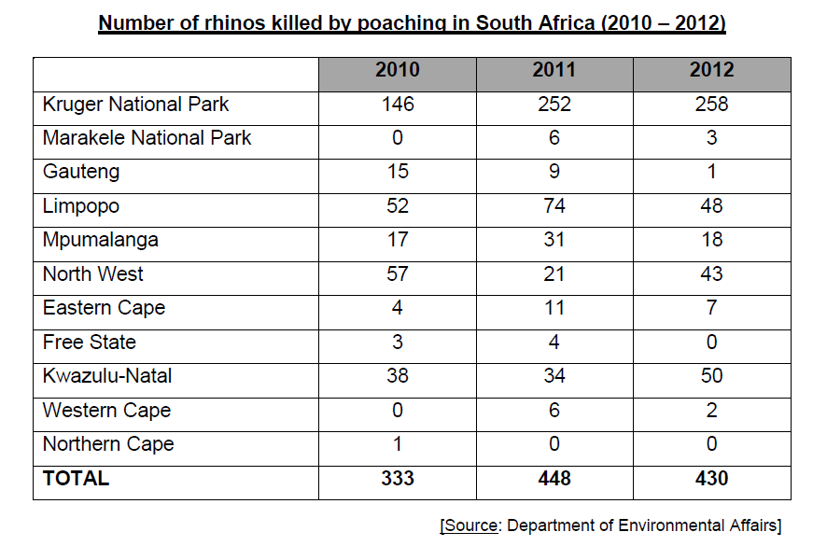



TEXT 4

TEXT 5

|  |
| --- |
| **An African Thunderstorm - David Rubadri**  From the west  Clouds come hurrying with the wind  Turning sharply  Here and there  Like a plague of locusts  Whirling,  Tossing up things on its tail  Like a madman chasing nothing.  Pregnant clouds  Ride stately on its back,  Gathering to perch on hills  Like sinister dark wings;  The wind whistles by  And trees bend to let it pass.  In the village  Screams of delighted children,  Toss and turn  In the din of the whirling wind,  Women,  Babies clinging on their backs  Dart about  In and out  Madly;  The wind whistles by  Whilst trees bend to let it pass.  Clothes wave like tattered flags  Flying off  To expose dangling breasts  As jagged blinding flashes  Rumble, tremble and crack  Amidst the smell of fired smoke  And the pelting march of the storm. |

TEXT SIX

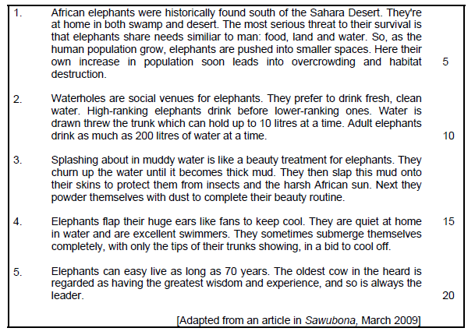

TEXT 7

