

**SOMERSET**

**EXAMINATION COVER SHEET**

**ENGLISH (HOME LANGUAGE) GRADE 8**

**PAPER 1 (LANGUAGE) DURATION: 1 ½ HOURS**

**DATE: THURSDAY 2 JUNE 2016 TOTAL MARKS: 95**

**EXAMINER: MS J MARTIN MODERATOR: MR G BUDD**

**INSTRUCTIONS:**

1. This paper consists of **three** sections. The reading texts are separate to the questions.

* Section A – Reading for understanding (Texts 1 – 3) 45 marks
* Section B – Language in context (Texts 4 - 7) 40 marks
* Section C – Summary (Text 8) 10 marks

1. Read the instructions carefully.
2. Answer the questions in complete, contextual sentences.
3. Look the mark allocation very carefully (PEE)
4. Answer the questions in any order, but NUMBER the questions correctly.
5. Please draw a margin on the right hand side of each page that you write on.

**Section A – Reading for understanding 45 marks**

**Text 1 - High Flight** **by John Magee**

Oh! I have slipped the surly bonds of Earth  
And danced the skies on laughter-silvered wings;  
Sunward I've climbed, and joined the tumbling mirth  
of sun-split clouds,-and done a hundred things  
You have not dreamed of-wheeled and soared and swung  
High in the sunlit silence. Hov'ring there,  
I've chased the shouting wind along, and flung  
My eager craft through footless halls of air....

Up, up the long, delirious, burning blue  
I've topped the wind-swept heights with easy grace  
Where never lark nor ever eagle flew-  
And, while with silent lifting mind I've trod  
The high untrespassed sanctity of space,  
Put out my hand, and touched the face of God.

**Text 2 Dulce et Decorum Est BY Wilfred Owen**

Bent double, like old beggars under sacks,

Knock-kneed, coughing like hags, we cursed through sludge,

Till on the haunting flares we turned our backs,

And towards our distant rest began to trudge.

Men marched asleep. Many had lost their boots,

But limped on, blood-shod. All went lame; all blind;

Drunk with fatigue; deaf even to the hoots

Of gas-shells dropping softly behind.

Gas! GAS! Quick, boys!—An ecstasy of fumbling

Fitting the clumsy helmets just in time,

But someone still was yelling out and stumbling

And flound’ring like a man in fire or lime.—

Dim through the misty panes and thick green light,

As under a green sea, I saw him drowning.

In all my dreams before my helpless sight,

He plunges at me, guttering, choking, drowning.

If in some smothering dreams, you too could pace

Behind the wagon that we flung him in,

And watch the white eyes writhing in his face,

His hanging face, like a devil’s sick of sin;

If you could hear, at every jolt, the blood

Come gargling from the froth-corrupted lungs,

Obscene as cancer, bitter as the cud

Of vile, incurable sores on innocent tongues,—

My friend, you would not tell with such high zest

To children ardent for some desperate glory,

The old Lie: Dulce et decorum est

Pro patria mori.

**Text 3 - The Delectable Hamburger Commercial**

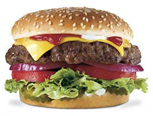

It is easy to make a delicious-looking hamburger at home. But would this hamburger still look delicious after it sat on your kitchen table under very bright lights for six or seven hours? If someone took a picture or made a video of this hamburger after the seventh hour, would anyone want to eat it? More importantly, do you think you could get millions of people to pay money for this hamburger?

These are the questions that fast food companies worry about when they produce commercials or print ads for their products. Video and photo shoots often last many hours. The lights that the photographers use can be extremely hot. These conditions can cause the food to look quite unappealing to potential consumers. Because of this, the menu items that you see in fast food commercials are probably not actually edible.

Let’s use the hamburger as an example. The first step towards building the perfect commercial hamburger is the bun. The food stylist—a person employed by the company to make sure the products look perfect—sorts through hundreds of buns until he or she finds one with no wrinkles. Next, the stylist carefully rearranges the sesame seeds on the bun using glue and tweezers for maximum visual appeal. The bun is then sprayed with a waterproofing solution so that it will not get soggy from contact with other ingredients, the lights, or the humidity in the room.

Next, the food stylist shapes a meat patty into a perfect circle. Only the outside of the meat gets cooked—the inside is left raw so that the meat remains moist. The food stylist then paints the outside of the meat patty with a mixture of oil, molasses, and brown food colouring. Grill marks are either painted on or seared into the meat using hot metal skewers.

Finally, the food stylist searches through dozens of tomatoes and heads of lettuce to find the best-looking produce. One leaf of the crispest lettuce and one centre slice of the reddest tomato are selected and then sprayed with glycerine to keep them looking fresh.

So the next time you see a delectable hamburger in a fast food commercial, remember: you’re actually looking at glue, paint, raw meat, and glycerine! Are you still hungry?

[Source: *englishforeveryone.org*]

**Section B – Language in context 40 marks**

**Text 4**

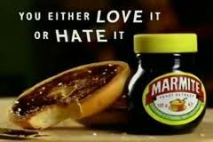**Text 5**

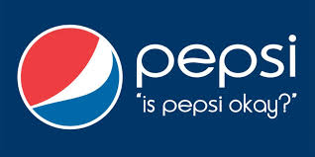

**Text 6**

It is all very well to say that I have done badly this term, but why take away my phone? You are not being fair! If you take away my phone, then I have no reason to work hard. You’ll see – you make my life miserable, and I’ll make YOUR life miserable.

**Text 7**

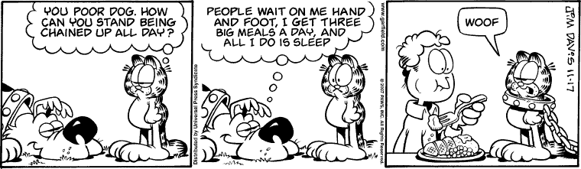

**Frame 1 Frame 2 Frame 3**

**Section C – Summary 10 marks**

**Text 8**

**Health benefits of drinking water**

Drinking water helps you lose weight because it flushes down the by-products of fat breakdown. Drinking water reduces hunger, it’s an effective appetite suppressant so you’ll eat less. Plus, water has zero calories.

Water also helps to relieve headache and back pains due to dehydration. Although many reasons contribute to headache, dehydration is the common one.

You’ll look younger when your skin is properly hydrated. Water helps to replenish skin tissues, moisturizes skin and increases skin elasticity.

Your brain is mostly made up of water, thus drinking water helps you think better, be more alert and more concentrated.

Water helps in digestion. Fibre and water go hand in hand so that you can have your daily bowel movement.

Proper hydration helps keep your joints and muscles lubricated, so you’ll less likely get cramps and sprains.

Drinking plenty of water helps fight against ’flu and other ailments like kidney stones and heart attack. Lemon juice added with water is used for ailments like respiratory disease, intestinal problems, rheumatism and arthritis, etc. In other words one of the benefits of drinking water is that it can improve your immune system.

You can now see the importance of water to your body after understanding the above benefits of drinking water.

[Source: *mangosteen-natural-remedies.com*]

**Section A Reading for understanding 45 marks**

**Texts 1, 2 and 3**

**Answer all questions in this section in full, contextual sentences. Marks will be deducted should you fail to do so.**

**Answer the following questions on Text 1**

**High Flight by John Magee 10 marks**

*High Flight* was written by 19-year-old American, John Gillespie Magee, a wartime Spitfire pilot with the Royal Canadian Air Force. He was killed in 1941 when his plane collided in mid-air. He sent this poem, written on the back of an envelope, to his parents weeks before the crash.

1. Why do you think the poem opens with the word “Oh!” What does it suggest about his feelings?(1)
2. The poet seems to find flight exciting. Pick one phrase that supports this view and explain your choice. (1)
3. How does flying make the poet feel? Pick out one word to support your idea and explain your choice. (1)
4. What do you think the poet means when he says, “and done a hundred things//You have not dreamed of?” (1)
5. Which words make the flight seem like a religious experience? Why do you think the poet might feel like this? (3)
6. Explain the scientific meaning of ‘…slipped the surly bonds of Earth’. (1)
7. Identify the figurative device in the following line: tumbling mirth/ of sun-split clouds (1)
8. How would poem inspire someone to learn to fly a plane? (1)

**Answer the following questions on Text 2**

**Dulce et Decorum Est by Wilfred Owen 20 marks**

1. The words Dulce et Decorum Est were widely understood and often quoted at the start of the First World War. Given the context of the poem, why are the lines ironic? (2)
2. How can we tell that the poet is horrified by the brutality of war? (2)
3. From which point of view is this poem written? (1)
4. Owen presents the soldiers as victims who have been betrayed by those who encouraged them to go to war. Prove this statement by quoting from the text. (1)
5. How can we tell that Owen is bitter about boys being encouraged to fight in wars? (3)
6. Why does Owen give such a detailed description of a soldier dying? (2)
7. Quote one simile from the text. Explain how it impacts on the reader. (2)
8. Refer to Text 1 and Text 2. Contrast the use of the interjection ‘Gas!’ in Text 2 with the use of the interjection ‘Oh!’ in Text 1. (2)
9. How would the poem be different if the last stanza weren't addressed to people at home? (2)
10. You are employed as a recruitment officer for the army and are speaking to a group of people, trying to convince them to join the army. Someone in the audience reads the poem, ‘Dulce et Decorum Est’ to you. How do you respond? (3)

**Answer the following questions on Text 3**

**The Delectable Hamburger Commercial 15 marks**

1. Explain why someone would possibly take a picture or make a video of a hamburger after the seventh hour. (1)
2. Which bright lights are being referred to in paragraph 1? (1)
3. Refer to paragraph 2.
4. Name the two types of advertisements mentioned in paragraph 2. (2)
5. What would you consider to be the fast food companies’ greatest concern when

shooting ads? (2)

1. What do you understand by the term ‘fast food’? (1)
2. In your OWN WORDS describe the job of a food stylist. (line 16) (2)
3. What other ingredients could possible cause the bun to become ‘soggy”? Mention TWO. (2)
4. Do you think fast food companies are being fair to their customers when shooting

advertisements? (2)

1. Has this article changed your view on fast food companies? (2)

**Section B – Language in context 40 marks**

**Texts 4, 5, 6 and 7**

**Text 4 10 marks**

1. What attracts the reader’s attention to this advertisement? (2)
2. Who is the target audience for this advertisement? [The people who would be interested in this advertisement] (1)
3. Write down the following:
4. The headline
5. The slogan (2)
6. Who placed this advertisement in the newspaper? (1)
7. What does the advertiser encourage the reader to do? (2)
8. What does the symbol “®” mean? (1)
9. Expand the contraction below:

Pipin’ hot pies. (1)

**Text 5 10 marks**

1. What is the function of a logo and slogan? (2)
2. Normally advertisers showcase the best aspects of their products. How has the marketing company challenged this perception in the adverts for Marmite, L’OREAL and Pepsi? (2)
3. Discuss how each advertising campaign challenges the traditional marketing campaign of each product. (6)

**Text 6 8 marks**

Refer to frame 1.

1. Are the words ‘poor dog’ being used literally or figuratively? (1)

Garfield asked the dog how (a) (b) stand being chained up all day. (2)

1. Refer to frame 2.
2. Describe Garfield’s body language in frame 2. (1)
3. Explain why Garfield displays this body language mentioned in 3.b. (2)
4. 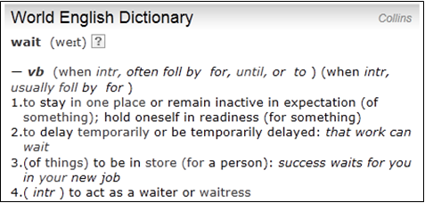Read the dictionary extract below:

1. Choose the correct dictionary meaning of the word ‘wait’ as it is used in frame 2. (1)
2. Use the word ‘wait’ in a sentence of your own to indicate a different meaning to the meaning in frame 2. (1)
3. What point is Garfield making in Frame 3? (2)

**Text 7 12 marks**

1. In the text, identify THREE examples of language where the child tries to manipulate his parents. Write down the sentences or parts of sentences that show manipulation. (3)
2. Rewrite the whole paragraph in a way that the parent would find more reasonable. (2)
3. Write sentences to continue the child’s conversation:
4. Write a simple sentence. (1)
5. Write a compound sentence. (1)
6. Write a complex sentence. (1)
7. Begin a complex sentence with a conjunction. (2)
8. Use a present participle as a verb. (2)

**Section C – SUMMARISING IN YOUR OWN WORDS 10 marks**

Carefully read **TEXT 8**. It promotes the drinking of water.

NOTE: You are required to do the following:

* Write seven full sentences in which you mention **SEVEN** health benefits of drinking water.
* Your 7 sentences should not consist of more than **60 Words**.
* Number your sentences from 1 to 7.
* Use your **OWN WORDS** as far as possible.
* Indicate the **TOTAL NUMBER OF WORDS** you have used in brackets at the **END** of your summary

**NOTE:** You will be penalised if you ignore these instructions.