

**ENGLISH PAPER 1 TEXTS**

**GRADE 6 NOVEMBER 2013**

**TIME: I HOUR 30 MINS 60 MARKS**

**INSTRUCTIONS**

* WRITE YOUR NAME ON THE LINED SHEET OF PAPER
* DRAW A MARGIN DOWN THE RIGHTHAND SIDE OF EACH PAGE
* Read the questions carefully in the 5 minutes reading time provided.
* Answer all questions on the **lined paper** provided.
* You may answer questions in any order.
* **Number the questions the same way they have been numbered on the question paper.**
* Work neatly and carefully.
* In this exam, you will be required to answer questions based on SIX different texts.
* Read the extracts very carefully before answering the questions.
* **Remember to answer in full sentences unless you are instructed otherwise.**

________________________________________________________________________

**ALLOWANCES**

* Dictionaries **may not** be used

**_______________________________________________________________________**

**EXAMINER**

J MARTIN

**MODERATOR**

R CODRINGTON

_________________________________________________________________________

**READING TEXTS**

**Question One 19 marks Extract from ‘Demon Dentist’ by David Williams**

The first thing you noticed about Miss Root was her teeth. She had the most dazzling white smile. Whiter than white. Like a fluorescent light. Her teeth were absolutely flawless. So flawless they couldn’t possibly be real. The second thing you noticed about Miss Root was that she was impossibly tall. Her legs were so long and thin, it was like watching someone walk on stilts. She was dressed in a white laboratory coat, like the one a Science teacher wears when it’s time for an experiment. Underneath the coat, her white blouse was matched by a long white flowing skirt. As she passed, Alfie looked down and noticed a large splash of red on the toe of one of her shiny white high-heel shoes.

Miss Root’s hair was white-blonde, and arranged in a perfectly *lacquered ‘do’, usually only spotted on the heads of Queens or Prime Ministers. The ‘do’ was shaped much like a McFlurry ice cream, minus the flake, of course. Finally Miss Root reached the front of the hall. She turned around and smiled. The low winter sun shone through the high windows and bounced off her teeth, causing the front few rows of children to cover their eyes.

“Good morning, children…!” she said brightly. The dentist spoke in a singsong manner, as if she were recounting a nursery rhyme. There was a collective groan from the kids at being spoken to as if they were toddlers. “I said, good morning, children…” repeated the dentist, and she fixed them all with a powerful stare. So powerful, that soon a hush descended upon the room. Then, in unison, all the assembled pupils said, “Good morning.”

“Let me introduce myself. I am your new dentist. My name is Miss Root, but I ask all my little patients like you to call me ‘Mummy’.” Alfie and Gabz shared a look of disbelief. “So can I hear a great big ‘Hello, Mummy’? After three! One, two, three…” Miss Root mouthed the words silently as the children joined in. “Hello, Mummy,” they murmured.

“Excellent! Now I came to this town when a very unfortunate, indeed fatal, accident befell Mr Erstwhile. The poor wretch must have fallen on to one of his own dental instruments. Oh, the irony! Of course there’s no need to go into all the gory details, but suffice it to say, Mr Erstwhile was found lying on the floor of his surgery in a huge pool of blood. The *dental probe was embedded deep in his heart…” A deafening silence descended on the hall. Alfie gulped. It was a horrifying image. Mr Erstwhile may have been old and doddery, but could he really have accidentally stabbed himself in the heart? “Mummy would like you all to give one minute’s silence for Mr Erstwhile. Now close your eyes, children. All of you. No peeping!” Alfie didn’t trust Miss Root enough to close his eyes. Nor did Gabz. Both screwed up their faces and squinted. From out of the tiny slits in his eyelids, Alfie spied something very strange. Instead of standing at the front with her own eyes closed, Miss Root tiptoed around the room inspecting all the children. When she finally reached Alfie’s row at the back, the boy squeezed his eyes tightly shut for fear of getting into trouble. Miss Root must have lingered looking at his face, as the boy could feel her cold breath on his skin for a while before she tiptoed back to the front of the hall. “And that’s one minute!” the dentist announced. “Thank you, children, you can open your eyes…”

Alfie and Gabz looked at each other again. They were the only two kids who had witnessed Miss Root’s peculiar behaviour… “Of course, Mr Erstwhile will be sadly missed. But as your new dentist, I asked your wonderful headmaster if I could come here today. Mummy wanted to give you all a chance to get to know me, so I can welcome each and every one of you personally to my surgery. Now I am going to begin today’s little talk with an incy-wincy question. Children, how many of you hate going to the dentist?” All but one kid put their hand up. No one actually enjoyed going to the dentist. At best it was tolerated. The one boy who didn’t put his hand up was too busy texting. Alfie reached his hand in the air as high as he could.

“Oh! So many hands. Ha ha!” she laughed, though not in a way that suggested she found it funny. “So how many of you REALLY REALLY hate going to the dentist…?” incanted Miss Root in that singsong voice of hers. Most of the hands stayed up, and Alfie actually rose out of his chair so his hand would be the highest. This boy was the king of really, really, really hating going to the dentist. After he had the wrong tooth pulled out, no one in the known universe hated going to the dentist more than Alfie. “Well, Mummy is here today to tell you there is absolutely nothing to be scared of…”The words danced in the air as she spoke. If her tone of voice was meant to sound reassuring, it didn’t. It sounded the opposite of reassuring. It was in fact decidedly * unreassuring. “Now I need a volunteer, hands up…!” said the dentist. All those little hands that had been up were now well and truly down. To avoid any confusion, Alfie shot his hands down to his feet. Any lower and they would be underground. He wanted there to be a less than zero chance that he would be picked.

“Nobody…?” asked Miss Root. Even the swots and show-offs kept deadly silent. “Come on, children, I don’t bite!” The dentist smiled and flashed her blindingly white teeth. “Who hasn’t been to the dentist for a very, very long time…?” she purred. The pupils started whispering to each other and looking around. Soon hundreds of pairs of eyes were glaring at Alfie. Everyone at school had at some point noticed his teeth. They were so bad, they might as well have been a tourist attraction. They could even have their own café and gift shop. The dentist followed the children’s gaze and fixed her eyes on Alfie. “Oh yes, I thought it might be you...” Miss Root’s long, thin, gnarled finger pointed straight at him. “You, boy. Come to Mummy…” When Alfie’s shaking legs finally propelled him to the front of the hall, he looked into the dentist’s eyes for the first time. Miss Root’s eyes were black. Blacker than oil. Blacker than coal. Blacker than the blackest black. In short, they were black. The dentist stared long and hard at the boy, before uttering…

“Don’t be scared, child…” There is nothing designed to scare a person more than being told not to be scared. “Let Mummy have a little look at your teeth…Oh…” moaned the woman in pleasure. “Your teeth are absolutely abhorrent…Well, young man, you simply must make an appointment to come and see me at my surgery very soon… Do you like presents, child…? Well, Mummy’s got a little present for you. For being such a good boy today, here – have a free tube of my own special brand of toothpaste…”

From the trolley, Miss Root picked up a thick white tube with the word ‘MUMMY’S’ emblazoned in big red letters on the side. “And one of my special toothbrushes. Do you prefer hard or soft bristles? The boy had had the same toothbrush all his life. He had no idea whether it once had been hard or soft. Right now there was only one lonely bristle left. It was virtually *bristleless.

“I don’t mind…”

“I’ll give you a nice soft one, then…” announced Miss Root. A gleaming white ‘MUMMY’S’ toothbrush was produced from the trolley. The bristles on the end were sharp and wiry. Alfie ran his finger along them and winced. It was like stroking a porcupine.

**Glossary**

Unreassuring (The author created this word. Not creating a sense of confidence.)

Bristleless (The author created this word.)

Lacquered (Sprayed with hair spray)

Dental probe (Dentist’s instrument)



**Question Two 9 marks**

Mosquitoes by David Campbell

Mosquitoes are blood relations

They doze on the white ceiling

Like the children upstairs

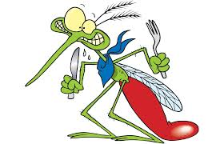While we wake below

We are their livelihood

They wish us no harm

Stealing through windows

With their fine instruments

And teething drone

There they say you hardly felt it

And they work like surgeons

While we stir in sleep

Tapping veins adjusting

The ﬂow dim

Figures at work murmuring

Creatures of the subconscious

Extinct cloaked vampires

Spirits hooked on blood

Live scarlet drops

Hanging like fruit bats

From the ceiling — our babies

Our own ﬂesh and blood

Loving us and jealous

Mmmmmm they cry at dusk

They are helpless without us.

**Question Three 7 marks Information about the structure of a tooth**

|  |
| --- |
| The crown is the part of the tooth that is visible above the gum (gingiva).  The neck is the region of the tooth that is at the gum line, between the root and the crown.  The root is the region of the tooth that is below the gum. Some teeth have only one root, for example, incisors and canine (‘eye’) teeth. Molars and premolars each have four roots.  The crown of each tooth has a coating of enamel, which protects the underlying dentine. Enamel is the hardest substance in the human body; harder even than bone. It gains its hardness from tightly packed rows of calcium and phosphorus crystals within a protein structure. Once the enamel has been formed during tooth development, there is a small amount of turnover of its minerals during life, but mature enamel is not considered to be a ‘living’ tissue.  The major component of the inside of the tooth is dentine. This substance is slightly softer than enamel, with a structure more like bone. It is elastic and compressible in contrast to the brittle nature of enamel. Dentine is sensitive. It contains tiny tubules throughout its structure that connect with the central nerve of the tooth within the pulp. Dentine is a ‘live’ tissue.  Below the gum, the dentine of the root is covered with a thin layer of cementum, rather than enamel. Cementum is a hard bone-like substance onto which the periodontal membrane attaches. This membrane bonds the root of the tooth to the bone of the jaw. It contains elastic fibres to allow some movement of the tooth within its bony socket.  The pulp forms the central chamber of the tooth. The pulp is made of soft tissue and contains blood vessels to supply nutrients to the tooth, and nerves to enable the tooth to sense heat and cold. It also contains small lymph vessels which carry white blood cells to the tooth to help fight bacteria.  The extension of the pulp within the root of the tooth is called the root canal. The root canal connects with the surrounding tissue via the opening at the tip of the root. This is an opening in the cementum through which the tooth’s nerve supply and blood supply enter the pulp from the surrounding tissue. |

**Question Four 6 marks**

Label the drawing. Simply write down the letter and its corresponding answer. You will find the information you need in the text for Question Three.(8)

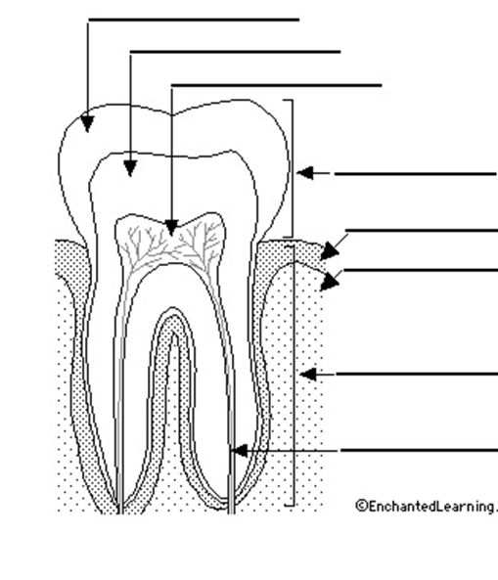

**Question Five 9 marks Colgate Kids**

**A**



**Question Six 10 marks Cartoons**

**A B**

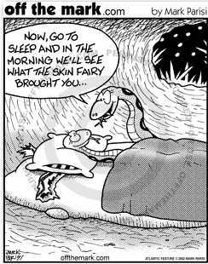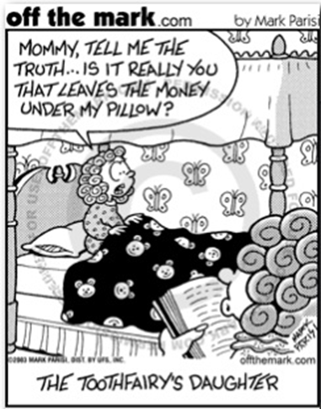

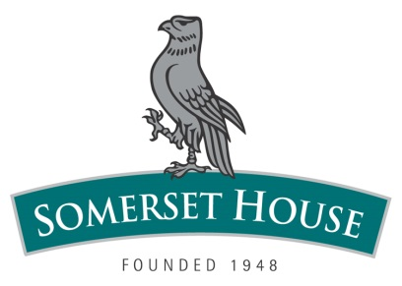

**ENGLISH PAPER 1 QUESTIONS**

**GRADE 6 NOVEMBER 2013**

**TIME: I HOUR 30 MINS 60 MARKS**

**INSTRUCTIONS**

* WRITE YOUR NAME ON THE LINED SHEET OF PAPER
* DRAW A MARGIN DOWN THE RIGHTHAND SIDE OF EACH PAGE
* Read the questions carefully in the 5 minutes reading time provided.
* Answer all questions on the **lined paper** provided.
* You may answer questions in any order.
* **Number the questions the same way they have been numbered on the question paper.**
* Work neatly and carefully.
* In this exam, you will be required to answer questions based on SIX different texts.
* Read the extracts very carefully before answering the questions.
* **Remember to answer in full sentences unless you are instructed otherwise.**

________________________________________________________________________

**ALLOWANCES**

* Dictionaries **may not** be used

**_______________________________________________________________________**

**EXAMINER**

J MARTIN

**MODERATOR**

R CODRINGTON

_________________________________________________________________________

**Question One 19 marks Extract from ‘Demon Dentist’ by David Williams**

**Answer the following questions in complete sentences. Pay careful attention to the mark allocation, and make sure that you keep your answers in context at all times.**

1. What two things are noticeable about Miss Root? (2)
2. Explain the meaning of the following sentence: ‘There was a collective groan from the kids at being spoken to as if they were toddlers.’ (2)
3. What happened to Alfie the last time he visited a dentist? (2)
4. What message was Alfie sending about dentists when he ‘reached his hand in the air as high as he could’? (2)
5. How else can we tell that he really hated going to the dentist? (2)
6. What word in the text tells us that Alfie’s peers were upset that he had not been to a dentist for a long time? (1)
7. Why do you think the author of the text describes Miss Root the way he does? (2)
8. Why do you think dentists have such a bad reputation? (2)
9. What effect does the writer want to create by saying that a ‘deafening silence’ fell.(2)
10. What connection do YOU make to the text? (2)

**Question Two 9 marks ‘Mosquitoes’ by David Campbell**

**Answer the following questions in complete sentences. Pay careful attention to the mark allocation, and make sure that you keep your answers in context at all times.**

1. The poet says that humans are blood relations of mosquitoes. What does this mean? (1)
2. What family ‘picture’ is the poet creating in the first stanza (verse)? (1)
3. What does the poet mean by ‘we are their livelihood’? (2)
4. Quote ONE other line from the poem that supports the poet’s view that mosquitoes are dependent on humans. (1)
5. Quote AND explain the meaning of ONE example of a simile from the poem. (2)
6. The mosquito is also described as an ‘extinct cloaked vampire’. What is this figure of speech? (1)
7. If you had to score the message/meaning of this poem out of ten marks, what mark would you give? Why? (1)

**Question Three 7 marks Information about the structure of a tooth**

**Read the information about teeth carefully before answering the questions below. You do not have to answer in full sentences.**

a. What is the visible part of the tooth is called? (1)

b. What is the name of the hard, white, outer layer of a tooth? (1)

c. What is the name of the tissue just below this outer layer? (1)

d. What is the bottom part of the tooth that anchors it in the gums and jawbone called? (1)

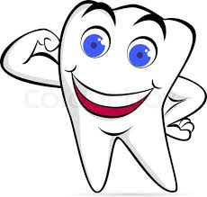e. What is the name of the soft centre of a tooth? (1)

f. What does this soft area contain? (2)

**Question Four 6 marks**

**Label the drawing. Simply write down the letter and its corresponding answer. You will find the information you need in the text for Question Three.(6)**

**Question Five 9 marks Colgate Kids**

**Study the screenshot carefully and use its information to answer the questions.**

1. Who is this website aimed at? Justify your answer carefully. (2)
2. Why do you think the products have been divided by age group? (1)
3. If there was product information for teenagers, name ONE topic that could be discussed. (2)
4. Why do you think that Colgate has associated their product with ‘SpongeBob Squarepants’?(1)
5. Which age group would most likely be attracted to play the games on the website?(2)
6. 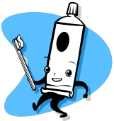The Home page of a website gives a general overview of the site, as seen by the screen shot. What do you think you would find were you to click on the ‘Colgate in Community’ page? (1)

**Question Six 10 marks Cartoons**

**Study the two cartoons carefully and answer the questions in full sentences**

1. Where would you be able to find more of these cartoons? (1)
2. Who is the artist responsible for drawing these cartoons? (1)
3. What is the title of Cartoon A? (1)
4. Who do you think is reading the story to the little girl in Cartoon A?(1)
5. What problem does this family face with regards to teeth being taken by the tooth fairy? (2)
6. Why is there a moulted snake skin under the pillow of the snake in Cartoon B? (2)
7. Imagine you are the artist, and have to draw another cartoon using the same idea/concept as in cartoon B, but with a different animal/creature. What would you draw? (1)
8. Explain why you think your new drawing would be funny. (1)

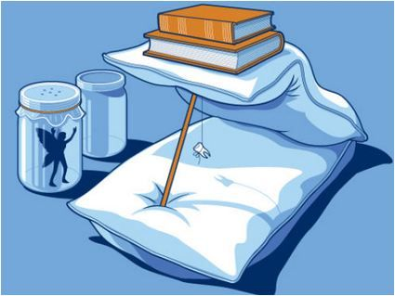

How to capture the Tooth Fairy.