SOMERSET

EXAMINATION COVER SHEET

ENGLISH (HOME LANGUAGE) GRADE 6

PAPER (LANGUAGE) DURATION: 2 Hours

DATE: THURSDAY 1 DECEMBER 2016 TOTAL MARKS: 75 marks

EXAMINER: MS J MARTIN MODERATOR: MR G BUDD

INSTRUCTIONS:
• Write your name on the lined paper that has been provided.
• Draw a narrow margin along the right hand side of each page
• This examination consists of TWO sections:
READING SKILLS (Questions 1-3) and GRAMMAR SKILLS (Questions 4-10)
• Answer questions 1 – 3 on the lined paper.
• You may answer the questions in any order.
• Number your answers correctly.
• Answer questions 4 – 10 on the question paper.

SOME

READING SKILLS 40 marks (Write your answers on the lined paper provided.)
SECTION A READING SKILLS

QUESTION ONE

Read the following news extract before answering the questions.

The mayor of Kos has warned of impending 'bloodshed' after chaos broke out among 1500 refugees who staged a protest at a football stadium, demanding food and shelter.
Yorgos Kyritsis issued the warning as the holiday island descended into a battlefield, with police spraying migrants with fire extinguisher foam in an effort to get them to disperse.
The incident took place during a registration procedure which was taking place at the stadium of Kos town, on the south east of the island.
Mr Kyritsus described the situation as being 'out of control', adding: 'There is a real danger of uncontrollable situations. Blood will be shed.'
He claims there are already 7000 migrants stranded on Kos which has a population of just 30 000 people. At times, the authorities have been unable to supply enough food and do not have enough space to house so many migrants, with more than 1 000 new arrivals landing from Turkey every morning. The Greek Prime Minister, Alexis Tsipras, said last week that the country, already battling an economic crisis, lacks the infrastructure to also deal with a migration crisis.
Greece's coast guard said it had rescued 329 migrants in seven separate search and rescue incidents off the coast of Lesbos and Kos in the 24 hours from Monday morning.
Those figures do not include the hundreds more who reach shore themselves in their inflatable dinghies from Turkey, making their own way to the islands' main towns for registration.
Greece has been overwhelmed by the number of migrants arriving, with at least 124 000 people reaching the eastern islands in the first seven months of this year alone.
In all, Greek police said Monday that 156 726 migrants had been arrested for entering or remaining in the country illegally from January through July 2015, compared to 32 070 for the same months in 2014.

Answer the questions carefully.
- Base your answers on the extract.
- Write your answers on the lined paper provided.
- Draw a marks margin.

- Why is the refugee situation ‘out of control’? (2)
- What is ironic about the holiday island descending into a battlefield? (1)
- A refugee is a person who has been forced to leave their country in order to escape war, persecution or natural disaster.
- Should it be compulsory for all countries to accept refugees? (2)
- How can refugees benefit a country? (2)
- What problems could arise from a country accepting refugees permanently? (2)

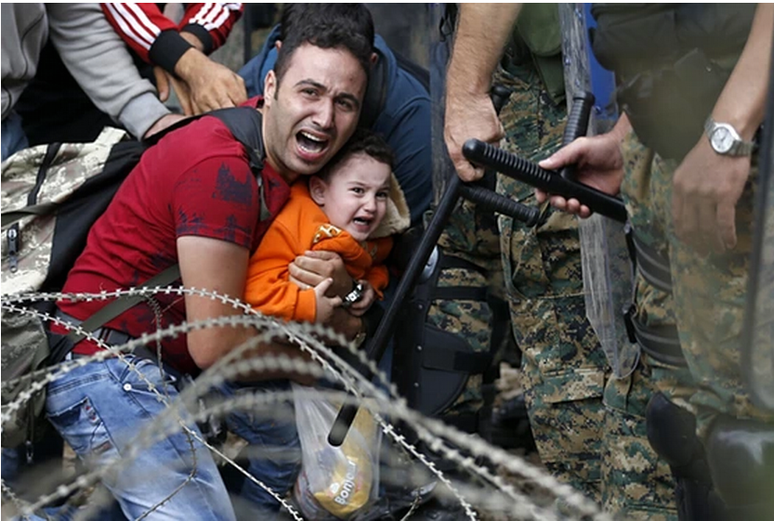

4. Which of the following captions is least suitable for the photograph above?
Explain your opinion carefully. (2)
- The crying child.
- Tears of fear.
- Like father, like son.
- The end of the road

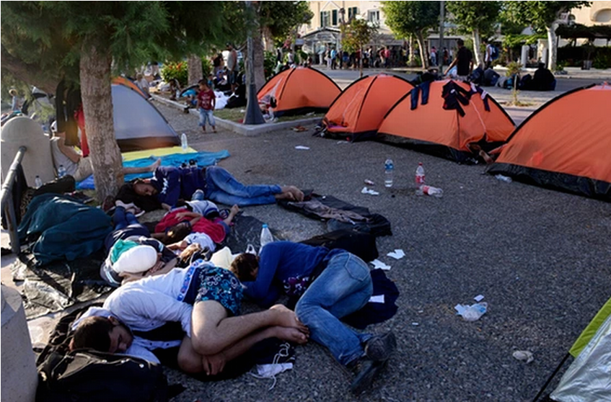

5. Write your own caption for the above photograph of refugees in Kos.
- From the perspective of the mayor. (1)
- From the perspective of a refugee. (1)

[13 marks]

QUESTION TWO

Read the following poem by Ted Kooser.

Abandoned Farmhouse
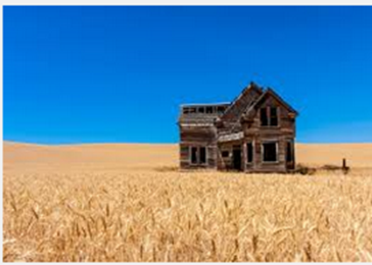
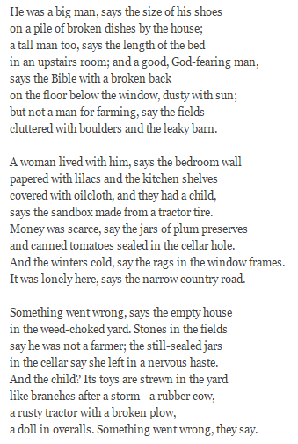

1. What personal qualities do you feel a farmer should have to survive on a farm? (2)
3. Name two points that show us the man was an unsuccessful farmer. (2)
3. Why do you think the poet grouped his ideas in the three stanzas as he did? (1)
4. Quote an example of personification in the poem. (1)
5. Quote an example of a simile in the poem. (1)
6. Quote an example of alliteration in the poem. (1)
7. Are the nouns in the poem actually speaking? Explain. (2)
8. How can we tell that the family left in a rush? (2)
9. In what way is their story different to that of the refugees in your previous text? (3)
[15 marks]

SECTION B
GRAMMAR SKILLS (Fill your answers in on the question paper.)

QUESTION THREE
Use the following extract to complete the Parts of Speech table.

Over the next half hour, Zafoona’s cheeks grew pale as Fadi could hear the echoes of her anguished wails as she pleaded to the other passengers to stop the truck, to go back to find her little Mariam. But the others looked away. They couldn’t stop, or they would all be arrested, or worse, killed. Noor held on to her mother’s sobbing body, trying to comfort her as best as she could, her horrified gaze flying from her father to Fadi. Habib tried to climb out of the truck, but the other men wrestled him to the floor. He would get himself killed – either from falling off the truck or by the pursuing Taliban.

Word in text | Part of speech | Word in text | Part of speech
cheeks |  | her
pale |  | but
echoes |  | wrestled
Mariam |  | falling
killed |  | pursuing

[10 marks]

QUESTION FOUR
Name the underlined parts of the following sentences.
- Fadi stood in the immigration line and looked around the sprawling airport.
____________________________________
- He gave Fadi a wink as the officer pulled out the pages.
____________________________________
- Cocooned in the flow of people, Fadi and his family were bundled into the house.
____________________________________

Question Four continued: Name the underlined parts of the following sentences.

- The men caught up on the latest news.
____________________________________
- There was a mad dash for the truck.
____________________________________ [5 marks]

QUESTION FIVE

Rewrite the following paragraph. Punctuate it correctly. There are no spelling errors.

Abay patted him on the face and passed him a glass of fizzy orange drink he gulped it down the coolness easing the dryness in his throat steaming plates of food were passed around as habib told them how it was only a matter of time before mariam was found nilufer piled a mound of rice and lamb onto fadis plate he dug in savouring the candied carrots and raisins
_______________________________________________________________________________________________________________________________________________________________________________________________________________________________________________________________________________________________________________________________________________________________________________________________________________________________________________________________________________________________________________________________________________________________________________________________________________________________________________________________________________________________________________________________________________________________________________________________________________________________________________________________________________________________________________________________________________________________
_______________________________________________________________________________________________________
[8 marks]

QUESTION SIX
Rewrite the following sentences in the specified tenses.
Underline the verbs.

1. The flight attendant interrupted Fadi’s thoughts. (future continuous)
______________________________________________________________________________________________________________________________________________________________________________________________________________
2. Fadi looked at her blankly. (past perfect)
______________________________________________________________________________________________________
__________________________________________________________________________________________________
3. Habib took the steaming trays of food. (present)
_______________________________________________________________________________________________________
_______________________________________________________________________________________________________
4. Fadi breathed a sigh of relief. (future perfect)
______________________________________________________________________________________________________________________________________________________________________________________________________________
[8 marks]

QUESTION SEVEN
Use the extract to write a conversation between Fadi and Mariam.
- Write the conversation in direct speech.
- Show that you understand how to use the introductory verb in three different ways.
- Only write THREE sentences.
With his eyes trained on the spot where his father had disappeared, Fadi started to run. Mariam clung to his hand, gasping for breath, trying to keep up.

__________________________________________________________________________________________________________________________________________________________________________________________________________________________________________________________________________________________________________________________________________________________________________________________________________________________________________________________________________________________________________________________________________________________________________________________________________________________________________
[6 marks]

QUESTION EIGHT
Use the picture as inspiration to write sentences as instructed.

- Write a simple sentence.
______________________________________________________________________________________________________________________________________________________________________________________________________
- Write a compound sentence.
______________________________________________________________________________________________________________________________________________________________________________________________________
- Start a sentence with a present participle.
______________________________________________________________________________________________________________________________________________________________________________________________________
- End a sentence with an adverbial phrase of place.
______________________________________________________________________________________________________________________________________________________________________________________________________
- Start a sentence with ‘Because’.
______________________________________________________________________________________________________________________________________________________________________________________________________
[10 marks]

