SOMERSET

EXAMINATION COVER SHEET

ENGLISH (HOME LANGUAGE) GRADE 7

LANGUAGE and COMPREHENSION DURATION: 1 HOUR

DATE: THURSDAY 9 JUNE 2016 TOTAL MARKS: 80

EXAMINER: MS J MARTIN MODERATOR: MR G BUDD

INSTRUCTIONS:
- This paper consists of TEN questions.
- Answer Questions 1 – 4 on lined paper.
- Please draw a margin down the right hand side of the lined paper.
- Answer the questions in complete, contextual sentences.
- Look the mark allocation very carefully (PEE)
- Answer the questions in any order, but NUMBER the questions correctly.
- Read the instructions carefully.

Question One 12 marks
Read the following extract, ‘Why the Whales Came’ by Michael Morpurgo. Answer the questions in full, contextual sentences.
“You keep away from the Birdman, Gracie”, my father had warned me often enough. ‘Keep well clear of him, you hear me now? And we never would have gone anywhere near him, Daniel and I, had the swans not driven us away from the dam under Gweal Hill where we always went to sail our boats.
We tried shouting at the swans; we even threw sticks at them. They simply ignored us, and cruised serenely around the pool, preening themselves. So reluctantly we gave up and took our boats to nearby Popplestone Bay, but we found it was so windy there that even on the calmest of days our boats would be capsized or beached almost as soon as we pushed them out. There was only one place left that we could go – Rushy Bay.
Rushy Bay was forbidden territory to us, along with most of the west coast of Bryher. We never asked why, for we did not have to. We all knew well enough that the west coast of the island was dangerous for children, whatever the weather. Mother and father reminded me repeatedly about it, and they were right to do so. At Shipman’s Head and Hell Bay there were black cliffs hundreds of feet high that rose sheer from the churning sea below. Here even on the calmest of days the waves would sweep you off the rocks and take you out to sea.
There was another more compelling reason though why we children were warned away from Rushy Bay and Droppy Nose Point and the west of the island, for this was the side of the island most frequented by the Birdman of Bryher. He was the only one who lived on that side of the island. He lived in the only house facing out over the west coast, a long low thatched cottage on Heathy Hill overlooking Rushy Bay itself. No one ever went near him and no one ever spoke to him. Like all the other children on the island, Daniel and I had learnt from the cradle that the Birdman was to be avoided. Some said the Birdman was mad. Some said he was the devil himself, that he fed on dogs and cats and that he would put spells and curses on you if you came too close.
The little I saw of Birdman was enough to convince me that all the stories we had heard were true. He was more like an owl, a flitting creature of the dark, the dawn and the dusk. Even in the hottest of summers he would always wear a black cape over his shoulders and a pointed sou’wester on his head. From a distance you could hear him talking loudly to himself in a strange, unearthly monotone. Maybe it was not to himself that he talked but to the kittiwake that sat always on his shoulder or to the donkey that pulled his cart wherever he went or maybe it was to the great woolly dog with the greying muzzle that loped alongside him. The Birdman went everywhere barefoot, even in winter, a stooped black figure that lurched as he walked, on step always shorter than the other. He rarely spoke to anyone, indeed, he scarcely even looked at anyone.

- Who is narrating the story? (1)
- How many people were in the family of the person narrating the story? (1)
- Why did the children stop sailing their boats on the dam under Gweal Hill? (1)
- Why did the children stop sailing their boats near Popplestone Bay? (1)
- The children were forbidden from going near Rushy Bay for two reasons.
- List the two reasons (2)
- Which reason was the main one? (1)
- What does ‘learnt from the cradle’ mean? (1)
- Who was the Birdman? (1)
- How do we know that the Birdman was unsteady on his feet? (1)
- The Birdman’s behaviour contributed to people believing that he was mad or the devil himself. Explain this. (2)

Question Two 15 marks

Read the following poem carefully. Answer the questions in full, contextual sentences.

The medicine chest by Belinda
My family lives inside a medicine chest:
Dad is the super-size band aid, strong and powerful
but not always effective in a crisis.
Mom is the middle-size tweezer,
which picks and pokes and pinches.
David is like the single small aspirin on the third shelf,
sometimes ignored.
Muffin, the sheep dog, is a round cotton ball, stained and dirty,
that pops off the shelf and bounces in my way as I open the door.
And I am the wood and glue which hold us all together with my love.

a. What does the first line of this poem actually mean? (1)
b. What is ironic about the father’s description? (1)
c. Do you think the poet has an accurate view of a mother? Explain your answer.(2)
d. Who do you think David is? (2)
e. Which member of the family has written the poem? (1)
f. Do you think the poet sees her family as being a perfect family? (1)
g. Quote an example of alliteration in the poem. (1)
h. Quote one simile from the poem (1)
I. What is being compared? (1)
II. What is the meaning of the simile? (1)
i. Examine the poem carefully. Do you think the writer should be the ‘wood and the glue’? (2)
j. The poem is written as a _____________________(Name the figurative device.) (1)

Question Three 8 marks
- List any THREE characteristics of persuasive speech, and give a clear example of each. (6)
- You are a judge of an essay writing competition, but the problem is that three people have all scored the same points, and there is only one prize that can be awarded. You ask each competitor to tell you why they should win the prize. Read their responses, and based on your understanding of persuasive techniques, choose the most persuasive response. Explain your decision carefully. (2)
DAVIDD
I should win the prize because I am so good at English. I do my homework every day, and I never make spelling mistakes. I do my work, I check my work and I am proud of my work. I am the future of the country. I am the best.

GRANNY MATILDA

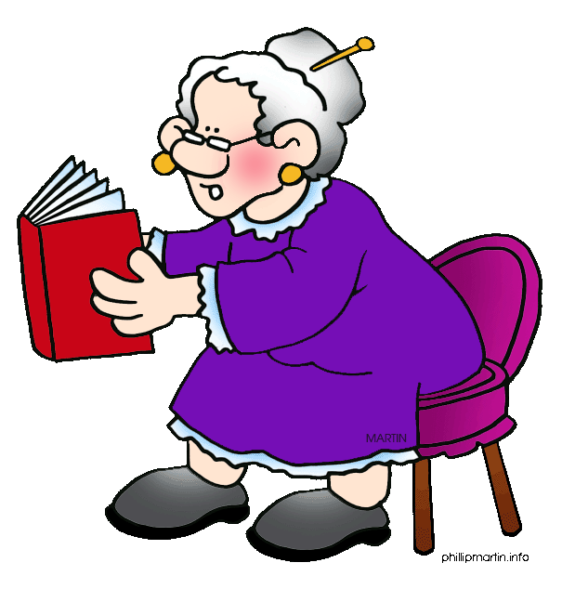
Oh no, no! I should win the prize, after all, I am an old granny and I deserve it more than anyone else! I have such a sore back, and such sore feet and such a sore hip – all because I have spent my whole life looking after my children, running a home and working like a slave. You wouldn’t want me to feel unappreciated, would you?

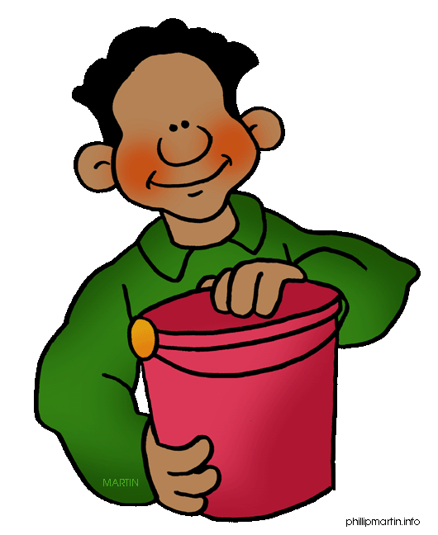
Wassup? Hey Dude, the prize must come to me! It would be so cool if I could win a prize and make my mother proud! C’mon now, be fair! Cool story, bro!

THE EGG-CELLENT EASTER CHICK-A-CHOC.
A
50% OFF FOR A LIMITED TIME!
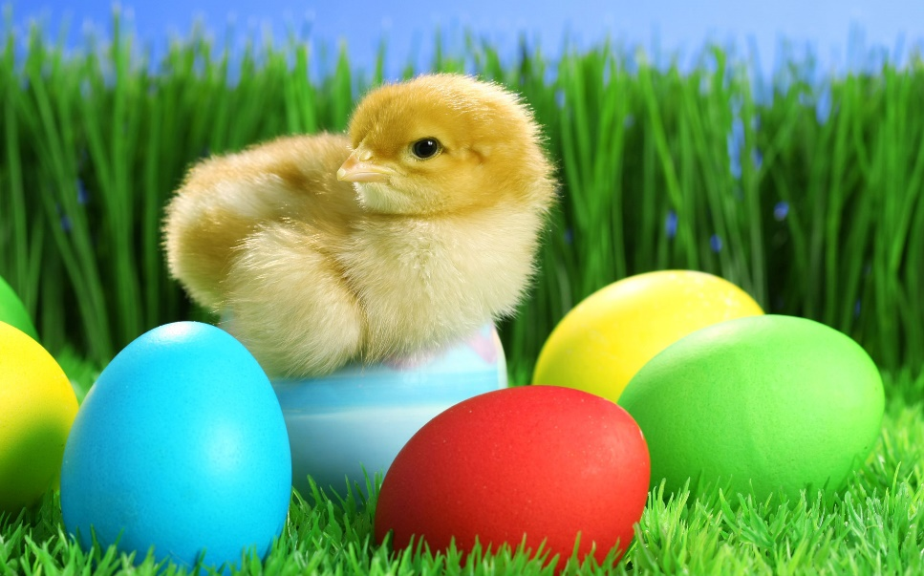
VOTED BEST EASTER GIFT OF 2014!
HURRY! WHILE STOCKS LAST!
B

C
ARE YOU LOOKING FOR A SUPER SPECIAL EASTER GIFT?
Want to buy something eggs-tra special this Easter?
Well look no further, help is here with the amazing new, EGG-CELLENT EASTER CHICK-A-CHOC here just for YOU! The EASTER CHICK-A-CHOC is like no other gift that you have ever been given before!
Each EASTER CHICK-A-CHOC includes an all-new, deeply, delicious chocolaty recipe AND your very own adorable Easter chick that hatches out of a chocolate egg! This eggs-tra-ordinary gift is available for YOU; just imagine receiving this special and sensational gift on Easter Day!
The EASTER CHICK-A-CHOC uses many breakthrough technologies including:
- Chick-cam technology – hook up your EASTER CHICK your PC, Mac, Tablet or Smart Phone and it will amaze and amuse your friends!
- Remarkably cute, fluffy and silky smooth - so your EASTER CHICK looks and feels like a live, newly hatched chick!
D
- The taste of chocolate heaven - your edible EASTER CHICK-A-CHOC egg is made from the most delicious, delectable dark and milk chocolate!
- Remarkable voice recognition technology - which allows you to communicate your EASTER CHICK by giving it voice commands as it responds to 25 programmable commands.
- Incredibly interesting and entertaining - your EASTER CHICK-A-CHOC will keep you entertained for hours and hours and will make you popular, particularly with your friends!
Get the EGG-CELLENT EASTER CHICK-A-CHOC this Easter and you’ll have the privilege of owning the most amazingly mind-blowing Easter gifts there has ever been!
M.I.M.OThe EASTER CHICK-A-CHOC can be purchased from Chocolate world Ltd for the small price of just £39.99 2014. Prices may vary according to the detail wanted. See in-store for details. Why not come and see the EASTER CHICK-A-CHOC for yourself at one of the stores? Book today, call 08867, 156345!
Question Four 10 marks
Study the advertisement on the previous page carefully before answering the questions about it.
- What is a ‘CHICK-A-CHOCK’? (1)
- Name and explain the humour of the title (See A) of the advertisement. (1)
- Is the statement at (B) a fact or an opinion? (1)
- What type of question is (C)? (1)
- What type of figurative language is found at (D)? (1)
- In which month would this advertisement be printed in a magazine? (1)
- List THREE other persuasive techniques used in this advertisement. (3)
- Is the CHICK-A-CHOCK good value for money? (1)

Question Five 10 marks
Identify the parts of speech of the underlined words, and write your answers in the table below.
- Ken Edwards, a British plumber, ate 36 cockroaches in one minute on the set of The Big Breakfast, London, England on March 5, 2001.

- In Australia there is an annual Cockroach Racing Championship and the winning roach scoops a top prize of $500.!
- It can easily live for a month without a head!
- Female cockroaches are larger than males because they produce and carry their eggs.
- A lobster is often called the cockroach of the sea since it is a scavenger.

WORD FROM TEXT | PART OF SPEECH | WORD FROM TEXT | PART OF SPEECH
Ken Edwards |  | easily
British |  | larger
is |  | because
and |  | their
scoops |  | it

Question Six 3 marks

Choose the words which best complete the following sentences. Circle the letter of the correct answer.
- Michel Lotito _______ eating metal and glass since 1959. Gastroenterologists have described his ability to consume 900 g of metal per day as "unique".
- is
- was
- had been
- has been

- ____ downright dangerous, but England's John Evans balanced a 159.6 kg Mini on his head for 33 seconds at The London Studios on May 24, 1999.
- its
- being
- It’s
- it’s

- It's downright dangerous, but _________ John Evans balanced a 159.6 kg Mini on his head for 33 seconds.

- England’s
- englands
- Englands
- england’s

Question Seven 4 marks

Join the following pairs of sentences with conjunctions. Choose the best conjunction each time.
- Our eyes are always the same size from birth. Our noses and ears never stop growing. (for/but)
__________________________________________________________________________________________________________________________________________________
- The Jules Lodge is an underwater hotel. Guests have to scuba dive to get to their rooms. (and/so)
__________________________________________________________________________________________________________________________________________________

Join the following sentences with conjunctions. Begin the sentence with the conjunction.

- Few people like snakes. They are dangerous. (because)

____________________________________________________________________________________________________________________________________________________
- Some people keep snakes as pets. They are dangerous. (Although)

__________________________________________________________________________________________________________________________________________________________________
Question Eight 8 marks

Provide antonyms or synonyms for the underlined words. Write your answers in the table below. Remember to keep the answers in context. You may write more than a single word as an answer.
A man who had spent 20 years in prison for bank robbery back in 1963 thought he would try again in 2003 in Spotsylvania County, Virginia, USA. He demanded and received several thousand dollars from two surprised bank cashiers and as he fled he spilled $100 notes in his wake as he attempted to stuff the cash into his pockets and get away. When he reached his hired getaway car he realised that he had locked his keys inside. This bungling burglar promptly took to his heels and fled the scene on foot followed by two passersby who grabbed him. The fleeing felon attempted to pull out his gun but failed, and shot himself in his leg but kept fighting his would be arresters; one of whom shot the suspect. The local police have charged the robber with 8 felonies, including robbery and 2 counts of attempted murder.
WORD IN TEXT | SYNONYM | WORD IN TEXT | ANTONYM
prison |  | bungling
surprised |  | promptly
spilled |  | grabbed
in his wake |  | failed

Question Nine 5 marks
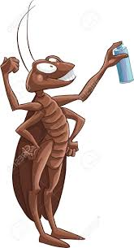
Using the picture of the cockroach as inspiration, write a different sentence for each of the verbs as specified. Underline the verb in your sentence.
a. auxiliary verb with present participle
b. being verb
c. action verb
d. linking verb

a_______________________________________________________________________________________________________________________________________________________
b_______________________________________________________________________________________________________________________________________________________
c_______________________________________________________________________________________________________________________________________________________d_______________________________________________________________________________________________________________________________________________________
Question Ten 5 marks
Write your own sentences about insects. Show you can write different types of sentences.
- Simple sentence: ______________________________________________________________________________________________________________________________________________
- Compound sentence:
______________________________________________________________________________________________________________________________________________
- Complex sentence:
______________________________________________________________________________________________________________________________________________

