SOMERSET

EXAMINATION COVER SHEET

ENGLISH (HOME LANGUAGE) GRADE 7

LANGUAGE and COMPREHENSION DURATION: 2 HOURS

DATE: THURSDAY 23 Nov 2017 TOTAL MARKS: 80

EXAMINER: MS J MARTIN MODERATOR: MR G BUDD

INSTRUCTIONS:
- This paper consists of NINE questions.
- The questions are based on texts found in the insert.
- Answer ALL questions on lined paper.
- Please draw a margin down the right hand side of the lined paper.
- Answer the questions in complete, contextual sentences.
- Look the mark allocation very carefully (PEE)
- Answer the questions in any order, but NUMBER the questions correctly.
- Read the instructions carefully.

SECTION A Response to texts 55 marks

QUESTION ONE 17 marks
Refer to TEXT 1

- Why do you think the leopard is running away? (1)

- The extract mentions that the black leopard has known fear twice. The second time is described in the extract. What do you think could have happened the first time that the leopard experienced fear? (2)

- Why is the leopard’s wound described as “dangerously out of reach of his tongue”? (2)

- What is mentioned as being unusual about the leopard’s movement in the first paragraph? (1)

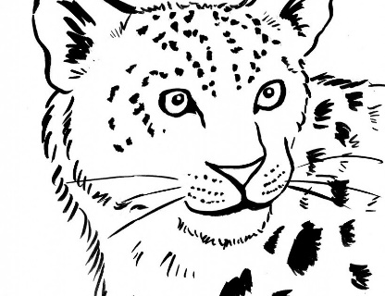
- Describe the leopard’s wounds. (2)

- Why do you think that some sounds are described as “alien”? (2)

- Describe the “midday medley” of a forest. (2)

- We read about a ‘shaft of sunlight that flooded over the leopard’.
- Name the figurative device (1)
- Define the figurative device (1)
- Discuss the meaning and effectiveness of the figurative device. (3)

[17 marks]

QUESTION TWO 10 marks
Refer to TEXT 2

Read the questions carefully. Only write the LETTER of the correct answer for questions 1 – 8.

- If you were to use the article as a reference for a speech, on which day would you deliver the speech?
- Day of Reconciliation.
- Heritage Day.
- Women’s Day.
- Freedom Day.

- Which ONE of the following best supports the purpose of the article?
- South Africans must appreciate the history and heritage they have in their own country and their own lives.
- More tourists must visit South Africa and especially the bushveld.
- South Africans must visit the bushveld to see the Big Five.
- South Africans must appreciate the wild life in their country.

- What is the purpose of the article?
- To challenge and inspire
- To inform and educate
- To encourage and motivate
- To criticize and discourage

- Which ONE of the following does NOT support the main idea of paragraph 1?
At Nambiti Private Game Reserve …
- you experience South Africa at its best.
- you experience 5-star luxury.
- you experience the sights and sounds of the bushveld.
- it is too dangerous to walk around because of wild animals walking around freely.

- What does the main idea of paragraph 2?
- That the Zulus defeated the British in the Anglo-Zulu War.
- There was a British garrison at Isandlwana.
- Wildlife should be appreciated.
- Nambiti has a rich history.

- What is the reason for the use of the inverted commas used with the words “to taste”?
- The writer is showing direct speech
- The writer is being silly.
- The writer is showing that the words are a translation from a foreign language.
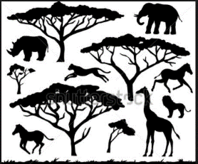
- The writer is hungry.

- Why did the author use a dash in line 11?
- It was used to indicate that an example will follow.
- It was used to indicate a change in thought.
- It was used to emphasise what follows.
- It was used to indicate emotion.

- Having read the entire article, why is A Taste for the Wild a suitable title?
- The article is about a place where you can leave your comfort zone behind in the city.
- The title is a link to the Zulu word “nambiti” which means “to taste”.
- Restaurants in game reserves serve good food.
- The article encourages visits to game reserves.

- The author refers to signing an “indemnity form”. What problems could the game reserve possibly face if they did not expect the guests and visitors to sign such a form? Name TWO problems. (2)

[10 marks]
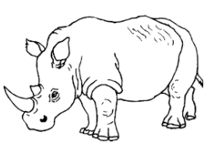

QUESTION THREE 5 marks
Refer to TEXT 3

You do not have to write your answers in full sentences.

- Which province had the highest number of rhinos killed in 2012? (1)
- How many rhinos has South Africa lost in total between 2010 and 2012? (1)
- How many provinces showed a decrease in the number of rhinos killed between 2011 and 2012? (1)
- Do you think the information provided is reliable? Give a reason for your answer. (2)

[5 marks]

QUESTION FOUR 10 marks
Refer to TEXT 4

- Explain why the words, '…it's an adventure' are written in large print. (1)
- Write an alternative heading for the advertisement. (2)
- What do the pictures suggest about Buffalo City? (2)
- Why has the advertiser included a map in this advertisement? (1)
- State any TWO ways in which tourists can get more information on Buffalo City. (2)
- Refer to the written text below the map in the advertisement.
What do the words 'like no other' suggest about Buffalo City? (1)
- Choose the correct answer. Write only the letter (A – D)
This advertisement has been placed by:
- www.tourismbuffalocity.co.za
- East London
- Tourism Buffalo City
- The Eastern Cape (1)

[10 marks]

QUESTION FIVE 13 marks
Refer to TEXT 5
- We read that the clouds are ‘like a madman chasing nothing’.
- Name this figurative device. (1)
- Explain what the poet means (1)
- Comment on the effect of this image. (What is your opinion of this description?) (2)
- In what ways are the clouds ‘pregnant’? (1)
- How do the children feel about the approaching storm? (1)
- Why do you think the children and adults have such differing opinions of the approaching storm? (3)
- Quote an image from the poem that suggests the danger and destructive qualities of the coming storm. (1)
- Quote and explain a metaphor from the poem. (3)
[13 marks]

SECTION B Language and grammar 25 marks

QUESTION SIX 6 marks

- Write down the abstract nouns found in the following sentence:

The black leopard was hungry and thirsty and weak from loss of blood but the sounds were retreating and he was not conscious of any immediate danger. (2)

- Write down the descriptive adjectives found in the following sentence:

From time to time he stopped to lick the steadily bleeding stump, listening for alien sounds. (2)

- Underline the adverbs in the following sentence:
Now in the cool forest he moved slowly on three legs in an unnaturally ungainly manner. (2)
[6 marks]
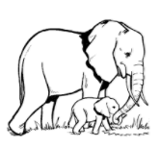
QUESTION SEVEN 9 marks

Refer to TEXT 6 which has some deliberate errors, and answer the questions.

- Combine the two sentences below to make a complex sentence.

African elephants were historically found south of the Sahara Desert.
They're at home in both swamp and desert. (1)

- Choose the correct answer. Write only the letter (A – D) next to the question number.
The apostrophe used in the word 'They're' (line 1) indicates ...
- the plural form.
- omission.
- possession.
- a quotation. (1)

- The word 'survival' (line 2) comes from the verb 'to survive.'
Give the correct form of the word 'survive' in the following sentence:
The elephant calf is the only (survive) of the fire on the game farm. (1)

- Correct the error in each of the following sentences: (6 x ½ mark)
- Elephants’ share needs similar to man: food, land and water (line 3).
- So, as the human population grow, elephants are pushed into smaller spaces (lines 3 – 4).
- Water is drawn threw the trunk (line 8 – 9).
- They are quiet at home in water and are excellent swimmers (lines 15 -16).
- Elephants can easy live as long as 70 years (line 18).
- The oldest cow in the heard is regarded as having the greatest wisdom and experience (lines 18 – 19).

- Give an antonym for 'harsh' (line 13). (1)

- Rewrite the following sentence, inserting all the missing punctuation marks:
I know said Themba that elephants have amazing memories (2)
[9 marks]

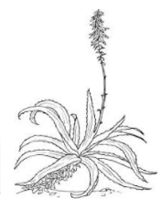
QUESTION EIGHT 6 marks

- Complete the following sentences by adding the missing question tags:
- Insects are not just all legs, ... ...? (1)
- An insect is not just all legs, ... ...? (1)

- Combine the sentences below to make a compound sentence:
Insects are very rich in fat.
Insects are very rich in protein. (1)

- Read the sentence below.
If you need to survive in the veld, flying ants can be trapped.
- Name this type of sentence. (1)
- Copy down the subordinate clause. (1)
- Copy down the verb in the independent clause. (1)

[ 6 marks]

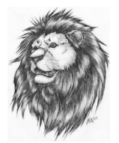

QUESTION NINE 4 marks

Correct the punctuation of the following sentences:
- The lion roaring loudly was a fearsome sight.
- Baking in the heat the lizard could hardly be seen.
- Should we go for a game drive Themba

[4 marks]

