SOMERSET

EXAMINATION COVER SHEET

ENGLISH (HOME LANGUAGE) GRADE 7

PAPER (COMPREHENSION AND LANGUAGE) DURATION: 2 Hours

DATE: TOTAL MARKS: 75 marks

EXAMINER: MS J MARTIN MODERATOR: MR G BUDD

INSTRUCTIONS:
- This paper consists of NINE questions.
- Answer Questions 1 – 2 on lined paper.
- Please draw a margin down the right hand side of the lined paper.
- Answer the questions in complete, contextual sentences.
- Look the mark allocation very carefully (PEE)
- Answer the questions in any order, but NUMBER the questions correctly.
- Read the instructions carefully.

QUESTION ONE
Read the information about tsunamis.
What causes a tsunami?
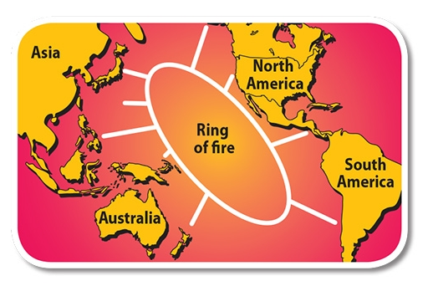
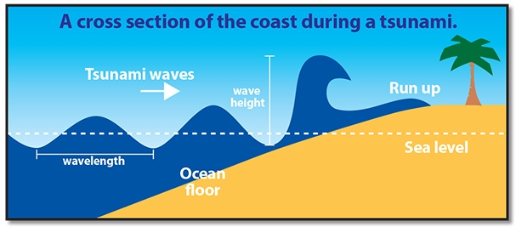

Meaning 'great harbour wave' in Japanese, tsunamis are sometimes called 'tidal waves' but their strength has nothing to do with the tides. About four out of five tsunamis happen within the Ring Of Fire, a zone in the Pacific Ocean where earthquakes and volcanic eruptions frequently take place.

Giant slabs of the Earth's crust, called tectonic plates, grind together. Sometimes, though, the plates get stuck, the pressure builds up and they suddenly slam into a new position. This causes an earthquake. If an earthquake lifts or drops part of the ocean floor, the water above rises and starts spreading across the ocean, causing a tsunami. Underwater landslides or volcanic eruptions can also displace water (cause water to spread across the ocean) and may lead to a tsunami.
How big is a tsunami?
Out in the open ocean, tsunami waves are only about one-metre high because the water is deep. However, as the water becomes shallow, the waves slow down and begin to grow. They can rise 35m or higher – that's the same as a 10-floor block of flats! However, the scariest thing about a tsunami is its wavelength, as this determines how far inland it can travel. Whereas a large wave caused by a storm might have a wavelength of up to 150m, a tsunami could reach up to a fearsome 1000km!

How fast is a tsunami?
A normal wind wave travels at about 90kmh, but a tsunami can race across the ocean at an incredible 970kmh! Sometimes, before a tsunami hits, there is a huge vacuum effect, sucking water from harbours and beaches. People can see the ocean floor littered with flopping fish and other sea animals. Then a wave blasts onto the shore minutes later, then another and another for two hours or more. There may also be up to one hour between each wave.
Can you predict when a tsunami is coming?
To save lives, scientists established the Pacific Tsunami Warning System, based in Hawaii, in the USA. Its network of detectors can track quakes that may cause a tsunami. These waves can race from one side of the Pacific Ocean to the other in less than a day, so people need to be warned in time to head for higher ground!

Answer the following sentences in complete, contextual sentences. Pay attention to the mark allocation for each question.

- Study the format of the text.
- Where would you find this type of text? (1)
- How does this text differ to the text for Question 2? (1)
- How reliable is the information of this text? Explain your opinion. (2)
- Why do you think the text has been structured the way it has? (2)
- Explain whether it is accurate for tsunamis to be called ‘tidal waves’. (2)
- What are the causes of tsunamis? (2)
- Why do most tsunamis occur in the Pacific Ocean? (1)
- A tsunami is a huge wave.
- What is the scariest thing about a tsunami? (1)
- Why can a tsunami travel so far across land? (1)
- Can a tsunami be prevented? Explain your opinion. (2)
- Can tsunamis be predicted? Explain your opinion. (1)
[16 marks]

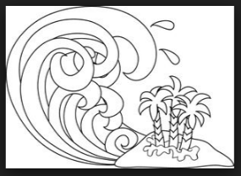

QUESTION TWO
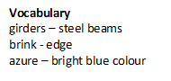
Read the following poem about the courage and concentration of a high diver.
High Dive by James Kirkup

It feels very lonely, up here against the clouds
and girders of the glass roof. The pool so far away,
framed in flowers of a thousand upturned faces.

Walk to the brink, turn, and carefully
(firm toes gripping this last hold on life)
hang heels in space. Face a blank wall.

Raise arms slowly, sideways, shoulder-high,
silent passion, dream-deep concentration
foretelling every second of the coming flight.

Then with a sudden upward beat of palms,
of arms like wings, gathering more than thought
launch backwards into take-off, into one ball

roll for a quadruple reverse somersault
that at the last second flicks
open like a switchblade –

feet pointed as in a prayer, neat-folded hands
stab the heavens like a dagger, plunge
deep into the pool’s azure flesh – without a splash.

Answer the questions carefully. Use full, contextual sentences.

- What feeling comes to the diver poised on the diving board? (1)
- Why would the diver feel lonely? (1)
- Why does the pool look like it is framed in flowers of a thousand upturned faces? (1)
- How does the poet show that the dive is dangerous? (2)
- What does the diver look like at the instant before take off? (1)
- What is the diver compared to in the last five lines of the poem? Discuss the effectiveness of this comparison. (2)
- The diver plunges ‘deep into the pool’s azure flesh’
- What figurative device has been used? (1)
- Why would the water be described as ‘flesh’? (1)
- What other word, earlier in the poem, supports this description? (1)
[11 marks]

QUESTION THREE
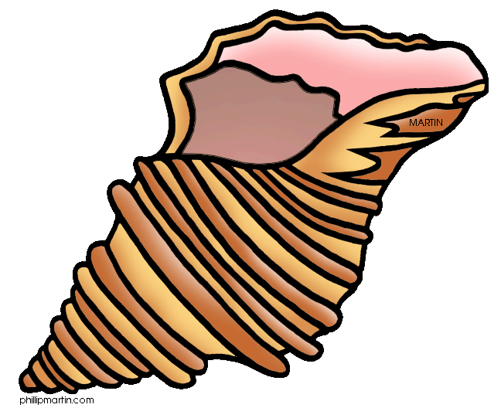
Read the poem and identify the PARTS of SPEECH of the bolded words. Write your answers in the answer box below the poem.
A Wave by Gussie Osborne

I sat on the beach and a beautiful wave

Came tumbling right up to me.

It threw some pink shells on the sand at my feet,

Then hurried straight back out to sea.

It ran away swiftly and leaped up in foam;

It bumped other waves in its glee.

I think it was hurrying to gather more shells,

To bring as a present for me.

Word in poem | Part of Speech | Word in poem | Part of Speech
I |  | ran
beach |  | swiftly
beautiful |  | and
up |  | its
threw |  | it
my |  | was hurrying

[12 marks]

QUESTION FOUR
Name each type of sentence.
- The biggest starfish is the sunflower star and it has more than 26 arms.
_______________________________________
- The starfish has an eye at the tip of each arm.
_______________________________________________
- Starfish can walk along underwater because they have ‘sticky feet’.
_______________________________________ [3 marks]
QUESTION FIVE
Fill in the missing words so that the sentences make sense. Write your answers in the answer box.
- When a dolphin is sick ___injured, its cries of distress summon immediate aid from other dolphins, who try to support it to the surface so that it can breathe
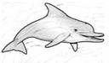
- The sailfish, the swordfish and the mako shark have all ____clocked at swimming over 80 km/hr.
- Dolphins sleep____ one eye open.
- Oysters can change ____one gender to another and back again depending on which is best for mating.
- A dolphin's hearing is ____acute that it can pick up an underwater sound from 24 kilometres away.
- Blue Whales weigh as ____as 30 elephants and are as long as three Greyhound buses.
- By swallowing water, the Pufferfish becomes ____big for other fish to swallow.
- A scallop ____35 blue eyes.
- The largest eggs in the world____ laid by a shark. [9 marks]
Sentence in text | Missing word | Sentence in text | Missing word | Sentence in text | Missing word
a |  | d |  | g
b |  | e |  | h
c |  | f |  | i

QUESTION SIX
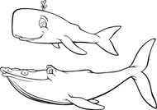
Carefully look at the bolded words in the following sentences. If they are adjectives, circle ‘YES’, and name the type of adjective it is. If it is not an adjective, circle ‘No’ and name the word’s part of speech.
- Octopuses are excellent climbers.
YES/ NO __________________________
- As a loggerhead turtle grows older, its head grows bigger.
YES/ NO _____________________
- Fish sleep behind rocks or seaweed.
YES/ NO __________________________
- The Mola Mola, or Ocean Sunfish, lays up to 5 000 000 eggs at one time.
YES/ NO __________________________
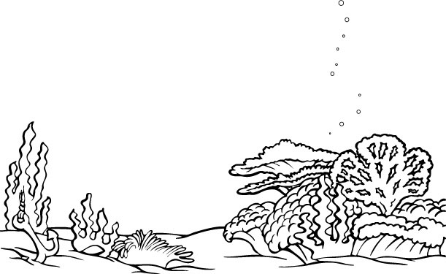
- Japanese fishermen are frequently criticised for hunting dolphins.
YES/ NO __________________________
- Left to their own devices, pearls grow naturally only once in every 20 000 oysters.
YES/ NO __________________________
[6 marks]

QUESTION SEVEN
Rewrite the following sentences in a different tense.
1. The crab will run on the beach. (Change into future perfect.)
_________________________________________________________________
2. The seagull has returned to the rock. (Present perfect continuous)
_________________________________________________________________
3. I am building a sandcastle. (Simple past)
_________________________________________________________________
[3 marks ]
QUESTION EIGHT
Rewrite the following paragraph so that it reads sensibly. Pay careful attention to the punctuation of the words and sentences. There are NO spelling mistakes.
sharks have the most powerful jaws on the planet both the sharks upper and lower jaws move a shark bites with its lower jaw first and then its upper it tosses its head back and forth to tear loose a piece of meat which it swallows whole a shark may grow and use over 20 000 teeth in its lifetime sharks never run out of teeth if one is lost another spins forward from the rows and rows of backup teeth two-thirds of a sharks brain is dedicated to its keenest sense smell
________________________________________________________________________________________________________________________________________________________________________________________________________________________________________________________________________________________________________________________________________________________________________________________________________________________________________________________________________________________________________________________________________________________________________________________________________________________________________________________________________________________________________
[8 marks]

QUESTION NINE
Read the following jokes, and rewrite them in direct speech. Each joke must be written in a different direct speech format.
Because they live in schools!
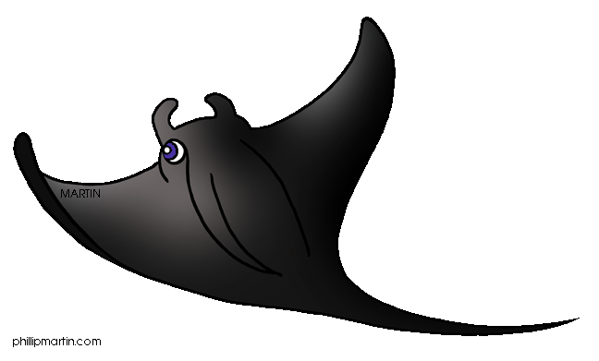
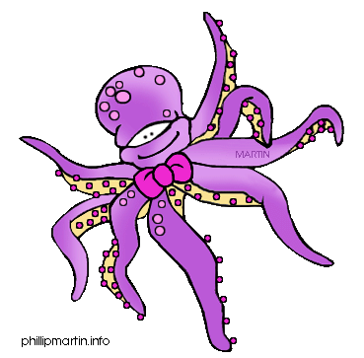
Why are fish so smart?

____________________________________________________________________________________________________________________________________________________________________________________________________________
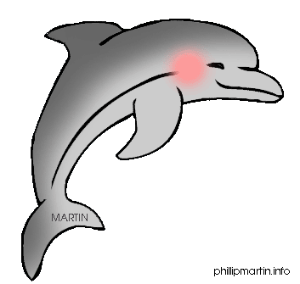
____________________________________________________________________
What sea animal can be adjusted to play music?

The tune-a fish!

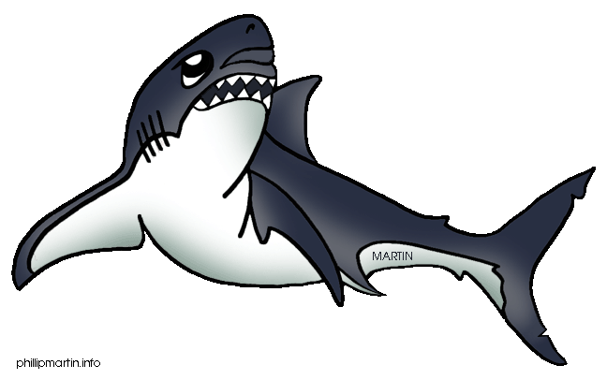

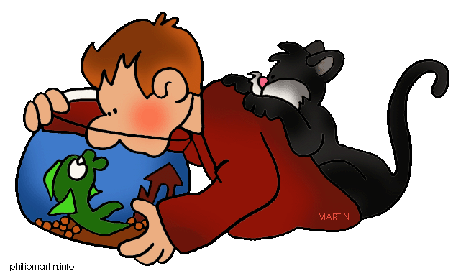
________________________________________________________________________________________________________________________________________________________________________________________________________________________________________________________________________________
Why is it so easy to weigh fish?

Because they have their own scales.

____________________________________________________________________
____________________________________________________________________
____________________________________________________________________
___________________________________________________________________
[7 marks]

