Section A Response to texts 60 marks
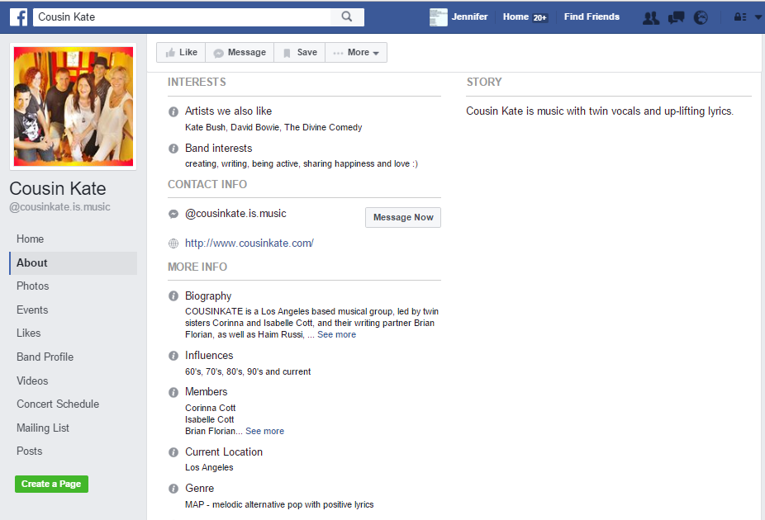
Text 1

TEXT 2

TEXT 2
"I Wish I Could Shimmy Like My Sister Kate"
I went to a dance with my sister Kate;
Everybody there thought she danced so great;
I realized a thing or two,
When I got wise to something new:
When I looked at Kate, she was in a trance,
And then I knew it was in her dance;
All the boys are going wild
Over sister Katie's style.
Oh, I wish I could I shimmy like my sister Kate;
She shimmies like a jelly on a plate.
My mama wanted to know last night,
What makes the boys think Kate's so nice.
Now all the boys in the neighborhood,
They know that she can shimmy and it's understood;
I know that I'm late, but I'll be up-to-date
When I shimmy like my sister Kate.
I mean, when I shimmy like my sister Kate.
Now I can shimmy like my sister Kate,
I know that I'm real late,
I think I'll do a real shimmy dance,
Dancing like my sister Kate,
Sweet papa, just like my sister Kate.

TEXT 3
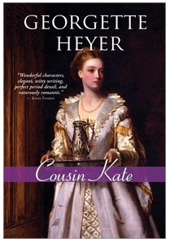
Guest review by Chris of book-a-rama
Kate Malvern just lost her job as governess and is staying with her old nurse Sarah until she gets a new situation. Sarah doesn’t like the idea of her Kate, whose father was a gentleman despite being a soldier and a gambler, hiring herself out to anyone who asks. Kate lived under all kinds of circumstances all over Europe so a little hard work doesn’t bother her. Still, Sarah can’t let it go so with the help of her crusty father-in-law, Mr. Nidd, she writes to the only relative Kate is aware of, Lady Broome of Staplewood.
At first, it looks like Lady Broome, or Aunt Minerva, is an answer to Kate’s prayers, offering her a place to stay for the summer. Kate starts to feel uneasy when Aunt Minerva gives her lavish gifts. There must be a catch. Lady Broome doesn’t seem like someone willing to give something for nothing. When she offers Kate a way to pay back her generosity, involving her handsome but unstable son, Torquil, Kate knows she has to get out of Dodge. Can she enlist the help of her other cousin Philip who thinks she’s a gold digger? Or rely on her own wits to disentangle herself from Staplewood?
Every Georgette Heyer novel I read becomes my new favourite and Cousin Kate is no exception. I loved Kate right from the beginning. She’s a practical girl with a sensible head on her shoulders. Plus, she’s sassy. She can go toe to toe with Lady Broome and her machinations. She also manages to charm just about everyone in the Staplewood household. Lord Broome treats her like a daughter and Torquil is calmer in her presence. Lady Broome is sufficiently nasty without becoming cartoonish. The dialogue between Philip and Kate is the best I’ve read from Heyer yet. Their back and forth is a lot like Elizabeth and Mr. Darcy. Philip never really gets the better of her.
Small sidenote: Jo Walton has done an excellent job discussing the Gothic novel of the 1950s, 1960s and 1970s. They all usually follow a very similar outline: a young girl without money, and usually with very few friends or relatives (if any) arrives at a Mysterious House to find Mysterious Doings, Secrets and Untrustworthy People. Usually a Sinister Hero is around and the girl must—gasp!—decide if she Trusts the Sinister Hero or Not. Often People End Up Dead, and the heroine is almost always in a Perilous Situation Requiring Rescue although sometimes she does manage to Rescue Herself only to be Clasped in the Hero’s Arms at the Last Minute. Often people are Very Proud. Too Proud. And they know Dark Family Secrets. It’s All Very Dangerous.

TEXT 4

Section B Language in Action 20 marks
TEXT 5

TEXT 6

Section C Summary 10 marks
TEXT 7

