Nettles by Vernon Scannell 30 marks
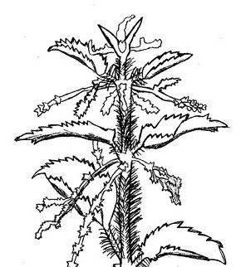
My son aged three fell in the nettle bed.
'Bed' seemed a curious name for those green spears,
That regiment of spite behind the shed:
It was no place for rest. With sobs and tears
The boy came seeking comfort and I saw
White blisters beaded on his tender skin.
We soothed him till his pain was not so raw.
At last he offered us a watery grin,
And then I took my billhook, honed the blade
And went outside and slashed in fury with it
Till not a nettle in that fierce parade
Stood upright any more. And then I lit
A funeral pyre to burn the fallen dead,
But in two weeks the busy sun and rain
Had called up tall recruits behind the shed:
My son would often feel sharp wounds again.
Make sure that you have read the poem carefully before you attempt to answer the following questions:
- What is this poem about? (2)
- Why does the poet say that ‘Bed’ is a curious name for those spears? (2)
- What do you think a ‘billhook’ could be? (1)
- The whole poem is actually a metaphor, using the nettles as part of the information.
  - What is a metaphor? (1)
  - What is the metaphor being explored in the poem? (2)
  - Quote ONE phrase or word that substantiates (proves) your previous answer. (1)
  - What is the meaning of the metaphor? (What is the message of the metaphor?) (2)
  - If you had to rename the poem to show its real meaning, what would your title be? (2)
- List three colours either mentioned or implied in the poem. (You may have to work out the colour.) (3)
- The poet has very strong feelings about the incident.
- How did the poet feel about the incident? (1)
- Quote ONE phrase or word that substantiates your previous answer. (1)
- Does the poem have a rhyming pattern? If so, write down the pattern. If not, explain your answer. (1)
- Give ONE example of alliteration in the poem. (1)
- Give synonyms for the underlined words, keeping the meanings in context of the poem. Write down the word and its synonym. (5)
- Give antonyms for the words in bold, Write down the word and its antonym. (5)

