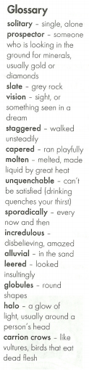
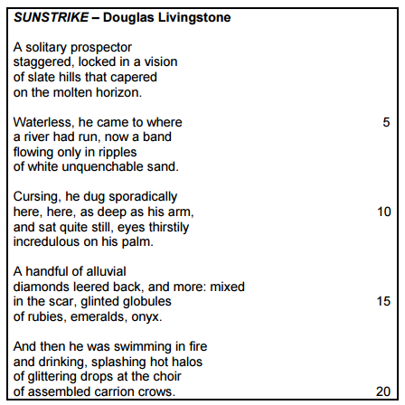
Unseen poetry – contextual questions - 20 marks

- What is the meaning of the poem? (2)
- Refer to stanza 1.
- Which word tells us that the prospector is unwell? (1)
- The prospector is seeing a mirage. Which word, apart from the word ‘vision’, tells us this? (1)
- How does this word imply maliciousness on the part of the hot earth? (2)
- Refer to line 8.
- Explain the irony in line 8. (2)
- Comment on the connotations of the word ‘unquenchable’ to explain why the poet uses this particular word. (2) Look at the context to see what is being described as unquenchable.
- Refer to lines 9 – 10.
- Why is the prospector cursing? (1)
- What is he digging for? (1)
- Why does the poet repeat ‘here’? (1)
- Refer to line 11. Why does he then suddenly sit quite still’? (1)
- Refer to lines 13 – 14.
- Identify the figure of speech. (1)
- Explain why the poet uses it. (2)
- Refer to stanza 4. What is the irony of his discovery? (2)
- Why does the poet mention carrion crows? (1)
- Explain why the title is so appropriate to the poem. (2)

Extension question
How does the imagery of the poem emphasise the irony between what the prospector wanted to find, and what he did find? Write an essay of 200 – 250 words. (10)

