War Horse Worksheet

- Study the picture carefully and base all your answers on it.

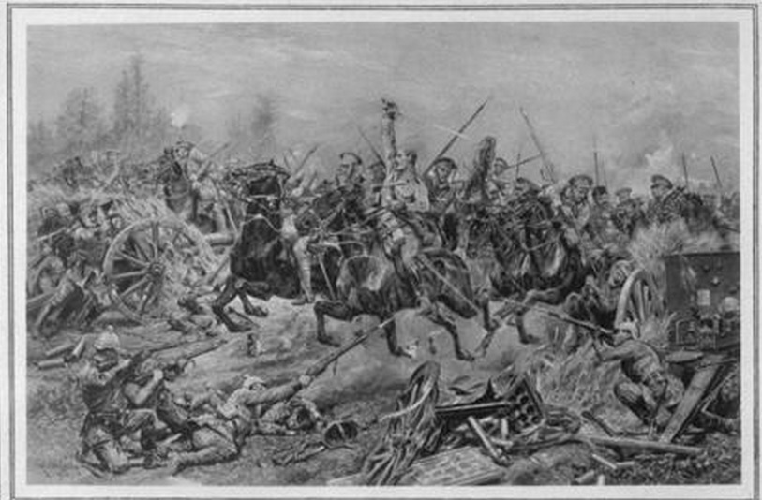
Two proper adjectives
Five proper nouns
Five common nouns

Seven descriptive adjectives
Five action verbs

- Continue to base all your answers on the drawing.
- Write three DIFFERENT direct speech sentences.

________________________________________________________________________________________________________________________________________________________________________________________________________________________________________________________________________________________________________________________________________________________________________________________________________________________________________________
- Write a sentence about the soldiers and underline the subject.

________________________________________________________________________________________________________________________________________________

- Write a sentence about the guns and underline the predicate.

________________________________________________________________________________________________________________________________________________
- Write a simple sentence.

________________________________________________________________________
________________________________________________________________________
- Write a compound sentence.
________________________________________________________________________________________________________________________________________________
f)Write a sentence with a word containing an apostrophe, but not a contraction.
________________________________________________________________________________________________________________________________________________

